

**VIVEKANAND COLLEGE FOR**

**ADVANCED COMPUTERAND INFORMATION SCIENCESURAT VEER NARMAD SOUTH GUJARAT UNIVERSITY, SURAT**

**PROJECT REPORT ON**

**Dental Homes**

**AS A PARTIAL REQUIREMENT FOR THE DEGREE OF BACHELOR OF COMPUTER APPLICATIN (B.C.A)2024-2025**

**GUIDED BY: SUBMITTED BY:**

**MS. Divya Gupta**

|  |  |
| --- | --- |
| **Laksh Lukhi N.** | **1775** |
| **Kathiriya Bhautik P.** | **1744** |
| **Jadav Darshil M.** | **1700** |

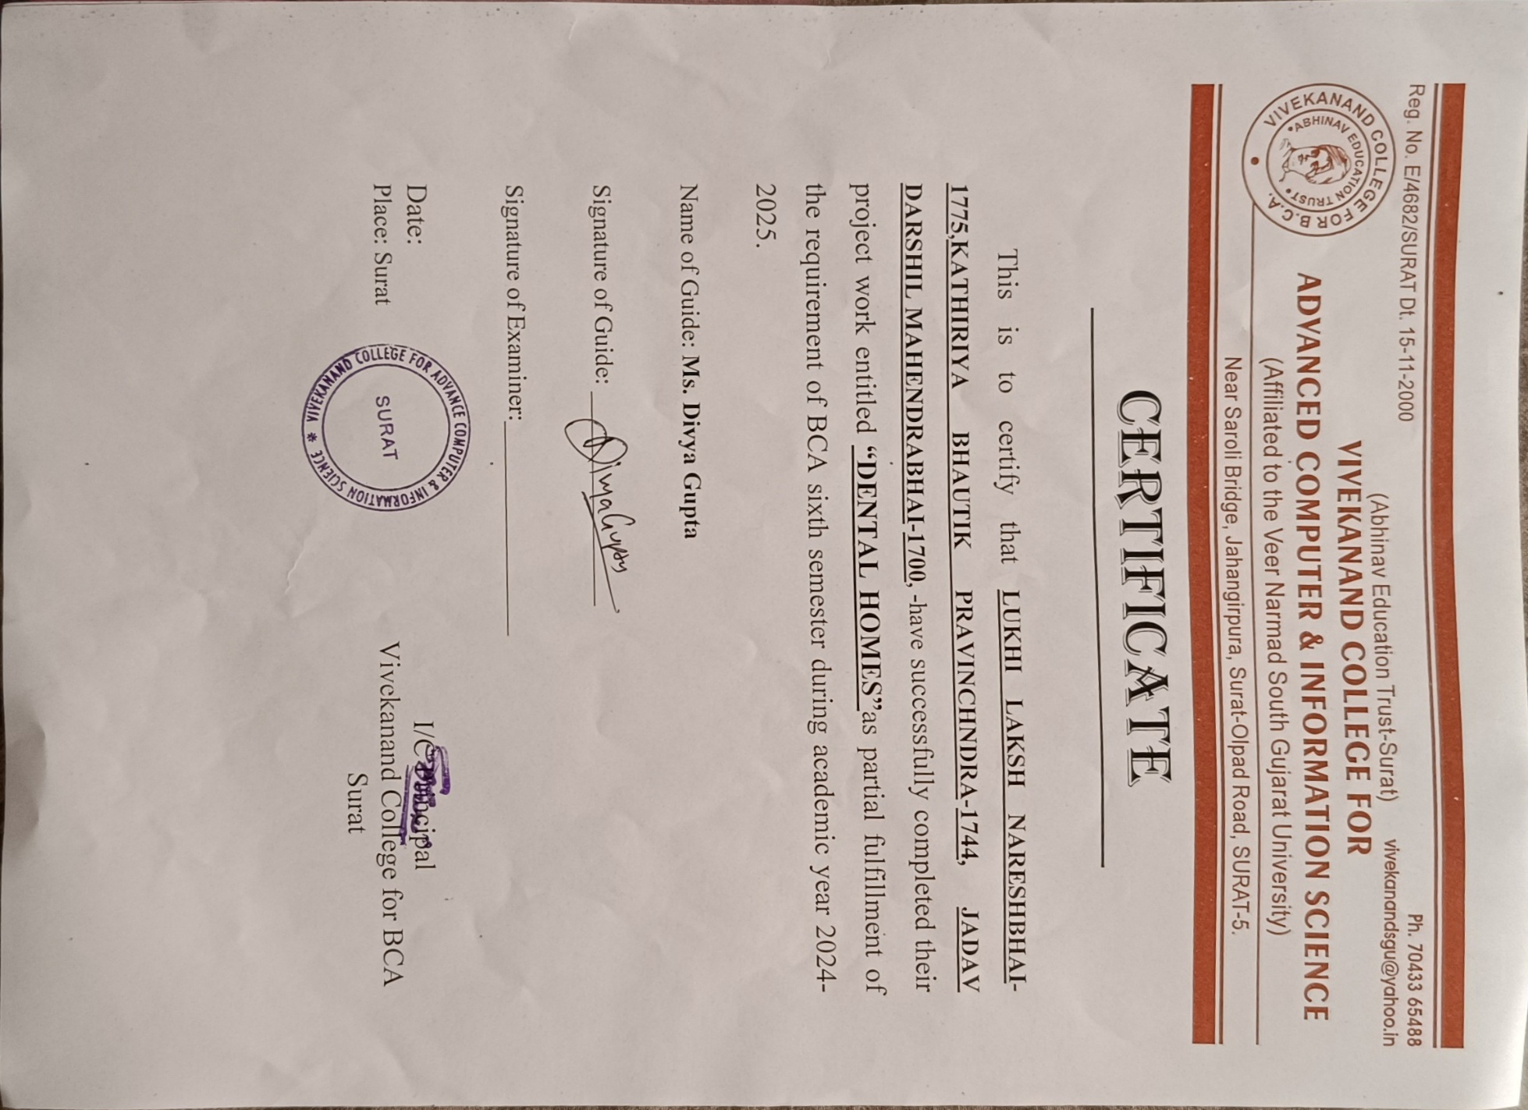

**ACKNOWLEDGEMENT**

I would like to express my gratitude and appreciation to all those who

gave me the possibility to complete this report. Special thanks is due to my

supervisor Mr. Hazami bin Che Hussain whose help, stimulating suggestions

and encouragement helped me in all time of fabrication process and in writing

this report. I also sincerely thanks for the time spent proofreading and correcting

my many mistakes.

I would like to express my gratitude and appreciation to all those who gave me the possibility to complete this project. Special thanks are to my mentor **Ms. Divya Gupta** whose help, stimulating suggestions and encouragement helped me in all time of fabrication process and in writing this report. I also sincerely thanks for the time spent proofreading and correcting my many mistakes.

I would also like to acknowledge with much appreciation the crucial role of the staff in B.C.A. Laboratory, who gave me a permission to use the lab equipment and also the machine and to design the drawing and giving a permission to use all the necessary tools in the laboratory.

Many thanks go to the all lecturers who have given their full effort in guiding me in achieving the goal as well as their encouragement to maintain our progress in track. My profound thanks go to all classmates, especially to my friends for spending their time in helping and giving support whenever I need it in fabricating my project.

**ABSTRACT**

I would like to express my gratitude and appreciation to all those who

gave me the possibility to complete this report. Special thanks is due to my

supervisor Mr. Hazami bin Che Hussain whose help, stimulating suggestions

and encouragement helped me in all time of fabrication process and in writing

this report. I also sincerely thanks for the time spent proofreading and correcting

my many mistakes

* **Wide Range of Services**:

The dental hospital offers a comprehensive range of services, including preventive care, restorative treatments, and orthodontics, catering to patients of all ages and dental needs. This extensive service array ensures that individuals seeking dental care can find suitable treatments under one roof.

* **Patient-Centric Approach**:

Each patient's journey is supported by detailed treatment plans, high-quality images of dental procedures, and testimonials, empowering patients to make informed decisions about their dental health. This wealth of information enables patients to understand their options and fosters trust in the care they receive.

* **Interactive Features**:

The platform includes interactive tools that allow patients to schedule appointments, access telehealth services, and receive personalized treatment recommendations based on their dental history and needs. These features enhance the overall patient experience, promoting accessibility and convenience.

* **Data-Driven Insights**:

Utilizing data analytics, the hospital can optimize its operations, improve patient outcomes, and tailor its marketing strategies to effectively reach the target audience. By analyzing patient data, the hospital can enhance its services and improve patient engagement.

* **Community Engagement**:

The project aims to build a vibrant community of patients and dental professionals, encouraging knowledge sharing and support through forums and discussion groups. This connection fosters a sense of belonging and helps patients feel more engaged in their dental health journey.

* **Technical Framework**:

Hospital Oversight is a web-based application developed using modern technologies such as PHP, AngularJS, and MySQL. This robust technology stack provides a secure and scalable foundation, enabling efficient management of patient data and dynamic content delivery.

**Table of Content**

|  |  |  |
| --- | --- | --- |
| **Sr. No.** | **Description** | **Page No.** |
| **1** | **Introduction** | **01** |
| **2** | **Environment Description** | **04** |
|  | 2.1 Hardware Requirements | **05** |
|  | 2.2 Software Requirements | **06** |
| **3** | **System Analysis and Planning** | **14** |
|  | 3.1 Existing System and its drawbacks | **14** |
|  | 3.2 Feasibility study | **15** |
| **4** | **Proposed System** | **16** |
|  | 4.1 Scope | **17** |
|  | 4.2 Project modules | **18** |
|  | 4.3 Module wise objectives and functionalities | **22** |
| **5** | **Detail Planning** | **25** |
|  | 5.1 Use-Case Diagram | **25** |
|  | 5.2 Flow chart | **27** |
|  | 5.3 Entity – Relationship Diagram | **43** |
| **6** | **System Design** | **41** |
|  | 6.1 Input design | **41** |
|  | 6.2 Output design | **50** |
|  | 6.3 Screenshots of the system | **53** |
| **7** | **Software Testing** | **84** |
| **8** | **Limitations and Scope of Enhancement** | **90** |
| **9** | **References** | **94** |

**1.Introduction**

The Hospital Oversight project is an initiative designed to elevate the standards of dental care through rigorous and consistent monitoring of dental hospitals. The core objective of the project is to ensure that dental facilities across various regions provide exceptional services, with a strong focus on patient safety, comfort, and overall well-being. In a sector as critical as healthcare, maintaining high standards is not just a requirement—it is a moral responsibility. The project believes that quality dental care is a fundamental right and works tirelessly to guarantee that every patient receives the best possible treatment under the safest conditions.

In an era where healthcare transparency and patient rights have gained prominence, the Hospital Oversight project takes the lead in establishing a reliable framework for assessing and evaluating the quality of dental services. Patients often face challenges when seeking dental care due to lack of information, unclear regulations, or inconsistencies in treatment quality. This initiative addresses such issues by creating a system where dental practices can be evaluated on multiple fronts, providing patients with trustworthy information that empowers them to make informed choices about their oral health.

The scope of the project encompasses all areas of dental practice, including preventive care, cosmetic dentistry, orthodontics, and restorative treatments. Each of these areas plays a vital role in promoting oral health and enhancing the quality of life. Preventive care ensures early detection of potential dental problems, while cosmetic dentistry boosts patients’ confidence through aesthetic improvements. Orthodontics helps correct dental irregularities for both functional and cosmetic benefits, and restorative treatments restore damaged teeth and improve overall dental function. The Hospital Oversight project considers these specialties in its evaluations to offer a complete picture of a dental hospital’s performance.

To accomplish its mission, the project employs advanced technologies and methodologies that allow for accurate data collection and analysis. This includes electronic health records, patient feedback tools, AI-based diagnostic systems, and regular audits conducted by trained professionals. These tools help gather insights on various aspects of patient care such as waiting times, staff behavior, cleanliness, availability of services, and the overall patient journey from registration to treatment completion. By using data-driven strategies, the project ensures objectivity in its assessments and provides actionable feedback for improvement.

One of the key components of the Hospital Oversight project is its emphasis on patient satisfaction. Patients are the central figures in any healthcare setting, and their experiences can reveal a great deal about the quality of care provided. The project encourages dental hospitals to adopt patient-centered approaches that prioritize empathy, communication, and respect for patient autonomy. Feedback mechanisms such as surveys, suggestion boxes, and online reviews are integrated into the evaluation process, helping hospitals identify strengths and address weaknesses in their service delivery.

Another crucial aspect of the project is monitoring treatment outcomes. While patient satisfaction reflects the service experience, treatment outcomes indicate the effectiveness of clinical procedures. The project tracks post-treatment recovery, complication rates, re-treatment needs, and long-term patient health status to determine how well hospitals meet clinical standards. These metrics provide a clear indication of whether patients are receiving appropriate and successful treatments, thereby reinforcing the need for skilled practitioners and updated medical protocols.

Safety protocols are also a significant area of focus. Dental procedures often involve the use of sharp instruments, exposure to chemicals, and close contact between patients and healthcare providers. Inadequate safety measures can lead to infections, injuries, or other health complications. The Hospital Oversight project enforces strict guidelines regarding sterilization, equipment handling, staff training, and emergency preparedness. Compliance with these safety protocols is critical to achieving accreditation and maintaining the trust of patients.

Education plays a vital role in the project's framework. Both healthcare providers and patients benefit from increased awareness and knowledge. For dental professionals, the project offers workshops, training programs, and access to the latest research in dental science.

For patients, educational materials such as brochures, videos, and interactive sessions are provided to help them understand dental procedures, preventive care routines, and the importance of regular checkups.

By promoting education, the project seeks to bridge the gap between professionals and the public, leading to better communication and care outcomes.

One of the long-term goals of the Hospital Oversight project is to build a culture of continuous improvement within dental hospitals. Rather than functioning as a regulatory body that only enforces penalties, the project aims to be a partner in progress.

Dental hospitals are encouraged to view evaluations as opportunities for growth and to use the feedback for internal development. This collaborative approach fosters innovation, professional development, and enhanced care delivery, creating a more resilient and responsive dental care system.

Accountability is at the heart of the project. When dental hospitals are held accountable for their services, they are more likely to invest in quality improvement. The project promotes transparency in hospital operations, encouraging open communication with patients about their rights, treatment options, and expected outcomes.

This openness builds trust between patients and providers, strengthens the reputation of dental institutions, and aligns the healthcare system with ethical standards.

The project also recognizes the importance of inclusivity and accessibility. Dental care must be available to all individuals, regardless of their socio-economic background, geographic location, or physical condition. As part of its evaluation process, the project assesses how well hospitals cater to diverse populations, including children, the elderly, and people with disabilities.

Hospitals are encouraged to adopt inclusive practices such as multilingual support, wheelchair accessibility, and financial assistance programs to make dental care more equitable.

Finally, the Hospital Oversight project invites stakeholders—including government agencies, private dental practitioners, academic institutions, and patient advocacy groups—to collaborate in achieving its vision.

By working together, these stakeholders can contribute resources, expertise, and policy support to strengthen the initiative. The collective effort will ensure that dental care in our communities is not only safe and effective but also compassionate and human-centered. The project stands as a testament to what can be achieved when vigilance, education, and a commitment to excellence come together for the greater good.

|  |  |
| --- | --- |
| Project Title | Hospital Oversight |
| Project Description | The **Hospital Oversight** project for a dental hospital is a web-based platform designed to optimize hospital management. It streamlines patient registration, appointment scheduling, dental treatment records, billing, and communication between doctors and patients. The system improves efficiency, enhances patient care, and provides a seamless experience for both staff and patients. |
| Name of Institute | Atmanand Saraswati Science Collage |
| Project Category Front-End Tool | HTML, CSS, Javascript, Bootstrap |
| Back-End Tool | PHP, MYSQL |
| Project Guide | Ms. Divya Gupta |
| Submitted By | Lukhi Laksh Nareshbhai  Kathiriya Bhautik Bipinchandra  Jadav Darshil Mahendrabhai |

1. **Environment Description**

The **Hospital Oversight** project requires a conducive environment supported by adequate hardware and software resources to ensure effective monitoring and evaluation of dental hospitals.

**2.1 Hardware Requirements**

* Client Side
  + Internet enable device with any browser that support bootstrap & JavaScript.
* Server Side
  + Desktop or Laptop Computers
  + Input Devices
  + Networking Equipment
  + Backup Storage
* Developer Side
  + RAM: 8 GB or above
  + Processor: Quad Core (Or Higer) CPU @ 2.00GHz 2.60 GHz

**2.2 Software Requirements**

* Client Side
  + Client On Internet: Chrome any Browser
* Server Side
  + Client On Internet: Chrome any Browser
  + Server: XAMP Server
  + Database: MYSQL
* Developer Side
  + Development IDE: Visual Studio Code
  + Operating System: Windows 10(64-bits)
  + Front-End Language: HTML, CSS, BOOTSTRAP, JS, jQuery
  + Back-End Language: PHP
  + Server: Apache server, XAMPP
  + Database: MYSQL
  + Network Interface: 10Mbps Interne

**TOOLS AND TECHNOLOGY**

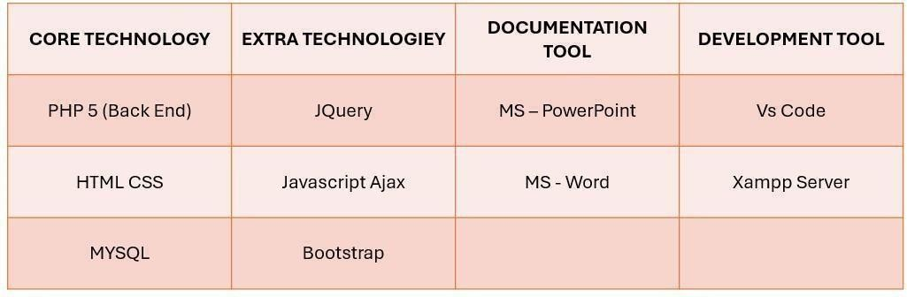

**CORE TECHNOLOGY**



* *About PHP/What is PHP*
* PHP Stands For Hypertext Pre-Processor.
* PHP was introduced by Rasmus Lerdorf in the first version and participate in the latest version.
* PHP is general-purpose scripting language and interpreter that is freely available and widely used for web development.
* PHP is a server side scripting language.

### **Purpose of Using PHP**

* PHP is mainly used for **server-side web development**
* It allows developers to **embed PHP code within HTML** to create dynamic and interactive web pages
* PHP can perform a wide range of tasks such as **handling form submissions**, **generating dynamic content**, **managing databases**, and **interacting with the server** for backend operations

**Advantages of PHP**

PHP is built specifically for web development, offering several key benefits:

* **Simple** – PHP is easy to learn, making it accessible for beginners
* **Fast** – Websites built with PHP generally have fast performance
* **Stable** – PHP is a mature language with a long history of reliability
* **Open-source and Free** – PHP is free to use, so there are no licensing costs for development
* **Strong Community Support** – A large, active community provides resources, tutorials, and assistance for developers facing issues



**About HTML / What is HTML**

* HTML stands for **HyperText Markup Language**
* It is the **standard markup language** used to create and structure web pages
* HTML combines **Hypertext** (which connects different web pages) and **Markup language** (which uses tags to structure and format content)
* HTML is easy to read and understand, using tags to define how elements should be displayed on a web page

**Purpose of Using HTML**

* HTML is used to **mark up and structure text** so that computers and browsers can interpret and display it correctly
* It helps define the layout and structure of web content using tags
* HTML is **supported by all major web browsers**, ensuring compatibility across platforms

**Advantages of HTML**

* HTML provides the **basic structure** for creating websites and is widely used across the web
* It is **easy to learn and implement**, even for beginners
* **Universal browser support** ensures that HTML works across all platforms
* HTML files are **lightweight and quick to load**, improving performance
* Large files can be handled efficiently using the **application cache** feature
* No need for additional software – HTML can be written using any basic text editor
* It has a **flexible and forgiving syntax**, making it beginner-friendly
* HTML files are **simple to edit and update**, since they are written in plain text



**About CSS / What is CSS**

* CSS stands for **Cascading Style Sheets**
* CSS is usually placed inside the <head> tag within a <style> element, or linked externally
* It is a **stylesheet language** used to control the presentation and layout of HTML or XML documents (including SVG, MathML, and XHTML)
* CSS is **easy to learn and understand**, even for beginners
* It provides **powerful control over the design and layout** of web pages
* CSS works in combination with HTML and XHTML to create well-structured and visually appealing websites

**Purpose of Using CSS**

* CSS allows you to define the **style and appearance** of XML or HTML elements
* Though originally created for HTML, CSS also works with **XML-based languages**
* It supports the **separation of structure (HTML) and presentation (CSS)**
* If HTML provides the content, CSS defines how that content should look
* **Three Types of CSS:**
  1. **Inline CSS** – Written directly within the HTML element
  2. **Internal CSS** – Defined inside a <style> tag in the HTML document's <head> section
  3. **External CSS** – Written in a separate .css file and linked to the HTML document

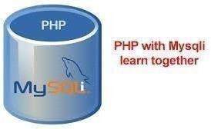

MySQL is an open-source relational database management system (RDBMS) that uses SQL (Structured Query Language) to access and manage data. It is widely known for being reliable, efficient, and easy to use. MySQL is a key component in many web applications and is a major part of the LAMP stack—Linux, Apache, MySQL, and PHP/Perl/Python.

❖ **Syntax**  
CREATE DATABASE mydatabase;

❖ **Example**  
CREATE TABLE users (  
id INT AUTO_INCREMENT PRIMARY KEY,  
username VARCHAR(50) NOT NULL,  
email VARCHAR(100) NOT NULL,  
created_at TIMESTAMP DEFAULT CURRENT_TIMESTAMP  
);

➤ **Advantages of MySQL**  
Open Source: MySQL is available for free and can be used and distributed without licensing costs, making it a budget-friendly choice for businesses.



**About JavaScript**  
JavaScript is a versatile, high-level programming language mainly used to add interactivity to websites. It is one of the core technologies of the World Wide Web, along with HTML and CSS. JavaScript allows developers to build dynamic, user-responsive applications by manipulating the Document Object Model (DOM), handling user events, and making asynchronous server requests.

**Advantages of JavaScript**

1. **Interactivity** – Enables the creation of dynamic and interactive web pages.
2. **Versatility** – Can be used for both front-end and back-end development (with Node.js).
3. **Rich Ecosystem** – Offers a wide range of libraries and frameworks like React, Angular, and Vue.js.
4. **Event-Driven** – Ideal for managing user interactions and real-time updates.
5. **Asynchronous Capabilities** – Supports asynchronous operations that enhance website performance.
6. **Cross-Platform** – Runs smoothly on any device or platform with a web browser.

**Disadvantages of JavaScript**

1. **Security Issues** – Susceptible to cross-site scripting (XSS) and other security vulnerabilities.
2. **Browser Inconsistency** – May behave differently across various browsers, causing compatibility issues.
3. **Performance Limitations** – Slower than compiled languages for intensive computations.
4. **Client-Side Dependency** – Relies on the browser, which can have JavaScript disabled.
5. **Dynamic Typing** – Lacks strict type checking, which can lead to unexpected errors during runtime.



**Bootstrap** is a widely-used open-source front-end framework designed to help developers create responsive, mobile-first websites quickly and efficiently. It comes with a comprehensive set of HTML, CSS, and JavaScript tools for building common UI elements like buttons, forms, navigation menus, and modals. Originally developed by Twitter, Bootstrap ensures a consistent design and smooth functionality across various browsers and devices.

**Advantages of Bootstrap**

1. **Responsive Design:** Its built-in responsive grid system and components ensure your site adapts seamlessly to different screen sizes.
2. **Consistent Appearance:** Offers a uniform look and behavior across all major browsers and devices.
3. **User-Friendly:** Easy to get started with, thanks to extensive documentation, community support, and ready-to-use examples.

**Disadvantages of Bootstrap**

1. **Initial Learning Curve:** While generally beginner-friendly, mastering all of its features may take time.
2. **Excessive Use of Classes:** Relies heavily on multiple class names, which can lead to cluttered and hard-to-maintain HTML.
3. **Generic Appearance:** Without customization, many Bootstrap-based websites tend to look alike.
4. **Performance Concerns:** Loading the full library may negatively impact page speed if only a few components are used.
5. **jQuery Dependency:** Some Bootstrap components require jQuery, which can increase the overall size of the webpage.
6. **System Analysis and Pl**

emphasizes the importance of a well-defined system for monitoring and evaluating dental care facilities. This section provides an analysis of the existing systems, their limitations, and the feasibility of implementing the proposed project.

**3.1 Existing System and Its Drawbacks**

The current systems used in dental hospitals for monitoring and evaluation are often inadequate in several aspects:

1. **Lack of Standardization**: Many dental hospitals operate with different standards and protocols for patient care and record-keeping, leading to inconsistencies in data quality and treatment outcomes.
2. **Manual Processes**: The reliance on paper-based records and manual data entry increases the risk of errors, data loss, and inefficiencies in accessing patient information.
3. **Limited Patient Feedback Mechanisms**: Existing systems may not effectively capture patient feedback on their experiences, leading to a gap in understanding patient satisfaction and areas for improvement.
4. **Inadequate Data Analysis Tools**: Many dental facilities lack advanced analytics capabilities to assess performance metrics, treatment outcomes, and patient demographics, limiting their ability to make data-driven decisions.
5. **Insufficient Integration**: The lack of integration between different systems (e.g., appointment scheduling, billing, patient records) can lead to fragmented information and hinder comprehensive patient care.
6. **Regulatory Compliance Challenges**: Existing systems may not fully comply with healthcare regulations, resulting in potential legal and financial risks.

**3.2 Feasibility Study**

A feasibility study is essential to evaluate the practicality and potential success of implementing the Hospital Oversight project. The study will consider various factors:

1. **Technical Feasibility**:
   * Assess the current technology infrastructure and its capacity to support the proposed system.
   * Evaluate the compatibility of new software and hardware with existing systems.
2. **Economic Feasibility**:
   * Analyze the costs associated with implementing the new system, including hardware, software, training, and ongoing maintenance.
   * Estimate potential cost savings through improved efficiency, reduced errors, and enhanced patient satisfaction.
3. **Operational Feasibility**:
   * Evaluate the organizational structure and readiness of staff to adopt the new system.
   * Consider the impact on existing workflows and identify necessary changes to facilitate integration.
4. **Legal and Regulatory Feasibility**:
   * Ensure that the proposed system complies with healthcare regulations, including data protection laws and patient confidentiality requirements.
5. **Schedule Feasibility**:
   * Establish a timeline for implementation, including phases for system development, testing, and rollout.

**4.Proposed System**

**4.1Scope**

The scope of the "Hospital Oversight" project encompasses a range of functionalities essential for the effective management of a dental hospital. The specific elements of the scope are outlined below:

* **Web-Based Platform**: Develop an intuitive, web-based system that is accessible via any device with internet connectivity, enabling stakeholders to use the system anytime, anywhere.
* **Patient Management**: Enable features for patients to book appointments, view their medical history, access treatment plans, and communicate with healthcare providers directly through a secure messaging system.
* **Doctor Management**: Equip doctors with tools to manage their schedules, access patient records, document treatment plans, and communicate with other healthcare professionals. This includes functionality for telemedicine consultations to accommodate remote patient care.
* **Responsive Design**: Ensure that the system is mobile-friendly and responsive, providing a seamless user experience across various devices, including smartphones, tablets, and desktops.
* **Data Analytics and Reporting**: Implement analytics tools to monitor user interactions and preferences, enabling data-driven decision-making for improving patient care and operational efficiency.
* **Administrative Management**: Enhancing operational oversight, compliance monitoring, and reporting for improved hospital administration.
* **Appointment Scheduling**: Implement a centralized appointment scheduling system that allows patients to book, reschedule, or cancel appointments, with notifications sent to both patients and doctors.
* **Search and Filter Options**: Provide robust search and filter functionalities that allow patients to find healthcare providers, services, and treatment options based on various criteria.
* **Responsive Design**: Ensure that the system is mobile-friendly and responsive, providing a seamless user experience across various devices, including smartphones, tablets, and desktops.
* **Data Analytics and Reporting**: Implement analytics tools to monitor user interactions and preferences, enabling data-driven decision-making for improving patient care and operational efficiency.
* **Custom Software Development**: The primary objective is to deliver a customized software solution that addresses the specific needs of a dental hospital, streamlining processes, reducing errors, and improving overall operational efficiency.
* **Doctor Permition**: Equip doctors with tools to manage their schedules, access patient records, document treatment plans, and communicate with other healthcare professionals. This includes functionality for telemedicine consultations to accommodate remote patient care.
* **Scheduling**: Implement a centralized appointment scheduling system that allows patients to book, reschedule, or cancel appointments, with notifications sent to both patients and doctors.

**4.2Project Modules**

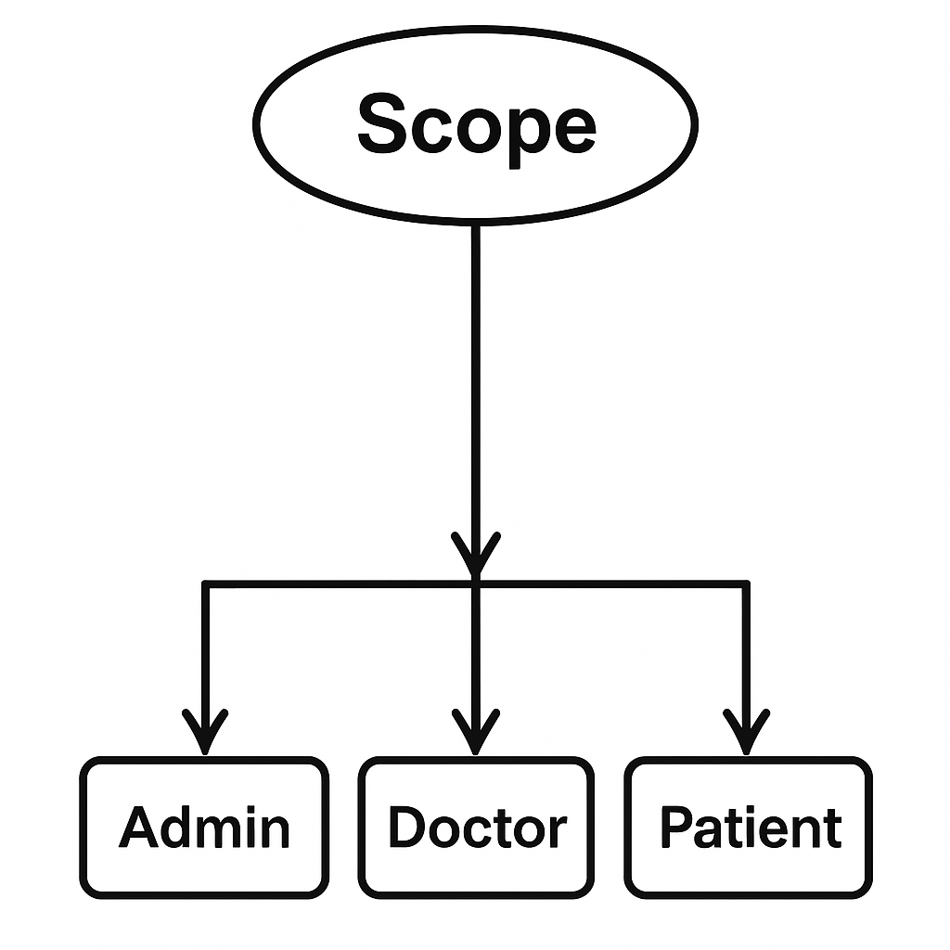

The **"Hospital Oversight"** system is organized into specific modules designed to address the needs of patients, doctors, and administrative staff, ensuring efficient management and operational oversight within the dental hospital.

* **PATIENT MODULE:**

1. **Patient Access**:
   * Patients can visit the portal to explore available dental services, treatments, and educational resources about oral health.
2. **Registration**:
   * The registration module allows new patients to create an account. Patients must provide personal information such as name, email, phone number, and password to access additional features and personalized services.
3. **Login**:
   * This module enables registered patients to log in to their accounts. After logging in, patients can access their medical history, schedule appointments, and manage treatment plans.
4. **Appointment Management**:
   * Patients can view available appointment slots, schedule new appointments, reschedule existing ones, and cancel appointments through this module. Notifications for reminders and confirmations are sent via email or SMS.
5. **Appointment History**:
   * Patients can view their past treatments, including details of procedures performed, dates, and the treating dentist, ensuring they have access to their complete dental history.
6. **Profile Management**:
   * Patients can update their personal information, including contact details and medical history, ensuring that their records are accurate and up-to-date.

* **DOCTOR MODULE:**

1. **Doctor Dashboard**:
   * Doctors have access to a dashboard displaying their schedule, upcoming appointments, and patient lists, providing a comprehensive view of their daily activities.
2. **Patient Management**:
   * This module allows doctors to view detailed patient profiles, including medical history, treatment records, and appointment details, facilitating personalized care.
3. **Appointment Scheduling**:
   * Doctors can manage their appointment slots, accept or decline patient appointments, and reschedule as necessary to ensure optimal patient flow.

* **ADMIN MODULE:**

1. **Admin Dashboard**:
   * The admin dashboard provides an overview of the hospital's operational metrics, including patient registrations, appointment statistics, and financial summaries.
2. **Patient Management**:
   * Admins can manage patient and doctor accounts, including creating new accounts, updating information, and deactivating accounts as needed.
3. **Appointment Management**:
   * Admins can view all scheduled appointments, manage schedules for doctors, and handle any conflicts or issues that may arise.
4. **Reports and Analytics**:
   * Admins can generate various reports, including patient demographics, service usage statistics, and financial performance, providing insights for strategic planning.
5. **Communication Management**:
   * Admins can oversee communication with patients and staff, ensuring timely responses to inquiries and maintaining effective communication flow.
6. **System Settings and Configuration**:
   * This module allows admins to configure system settings, manage user roles and permissions, and maintain overall system integrity and security.

**4.3Module wise objectives and functionalities**

The **"Hospital Oversight"** system aims to enhance the management of dental care services, improving efficiency and patient satisfaction through various functionalities in the patient, doctor, and admin modules.

* **PATIENT MODULE:**

1. **Comprehensive Service Range**:
   * Provide a wide selection of dental services and treatments, including preventive care, cosmetic dentistry, orthodontics, and oral surgery, catering to diverse patient needs.
2. **Appointment Scheduling**:
   * Enable patients to easily book, reschedule, or cancel appointments through an intuitive interface, ensuring convenience and accessibility.
3. **Detailed Appointment Information**:
   * Offer comprehensive descriptions of dental procedures, including benefits, risks, recovery, and costs, helping patients make informed decisions about their dental care.
4. **Secure Patient Records**:
   * Implement secure storage for patient medical histories, treatment plans, and prescriptions, ensuring confidentiality and easy access for both patients and healthcare providers.
5. **Patient Accounts and Profiles**:
   * Allow patients to create and manage personal accounts, saving their preferences, appointment history, and treatment details for future reference.
6. **Book Appointment for Treatments**:
   * Provide real-time tracking of treatment progress and follow-up appointments, ensuring patients stay informed about their dental care journey.

* **DOCTOR MODULE:**

1. **Doctor Dashboard**:
   * Provide a personalized dashboard for doctors to manage their schedules, view patient appointments, and access treatment histories at a glance.
2. **Patient Management**:
   * Allow doctors to view and update patient profiles, including medical histories, treatment records, and notes, facilitating personalized patient care.
3. **Appointment Management**:
   * Enable doctors to manage their appointment schedules, accept or decline patient bookings, and set availability, ensuring efficient time management.
4. **Treatment Documentation**:
   * Allow doctors to document treatments performed, update patient care plans, and ensure accurate records are maintained for every patient.
5. **Analytics and Reporting**:
   * Enable doctors to access performance metrics, including patient outcomes and service utilization, for ongoing improvement and informed decision-making.

* **ADMIN MODULE:**

1. **Admin Dashboard**:
   * Provide an overview of hospital operations, including patient statistics, appointment schedules, and financial reports, facilitating effective management.
2. **Patient Management**:
   * Allow admins to manage patient and doctor accounts, including the ability to add, edit, or deactivate accounts as necessary for security and efficiency.
3. **Appointment Oversight**:
   * Enable admins to oversee all scheduled appointments, manage conflicts, and ensure that the scheduling system operates smoothly.
4. **Reports and Analytics**:
   * Generate comprehensive reports on patient demographics, service utilization, and financial performance, providing insights for strategic planning.
5. **System Configuration**:
   * Allow admins to configure system settings, manage user roles and permissions, and ensure overall system security and integrity.

**5.Detail Planning**

**5.1 Use-Case Diagram:**

1. **Use-Case for Admin:**

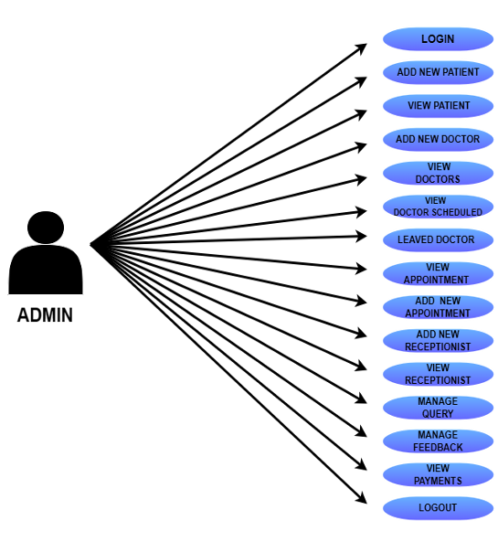

1. **Use-Case for Doctor:**

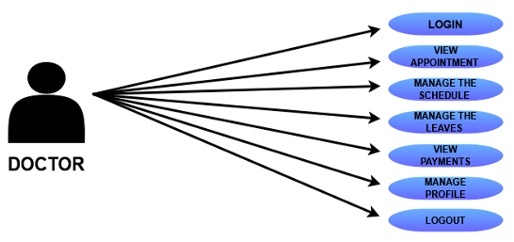

1. **Use-Case for Patient:**

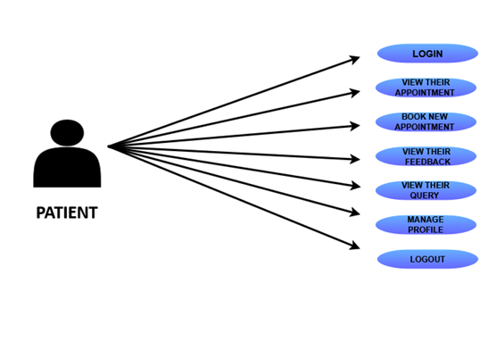

**5.2 Flow Chart:**

**1. Admin:**

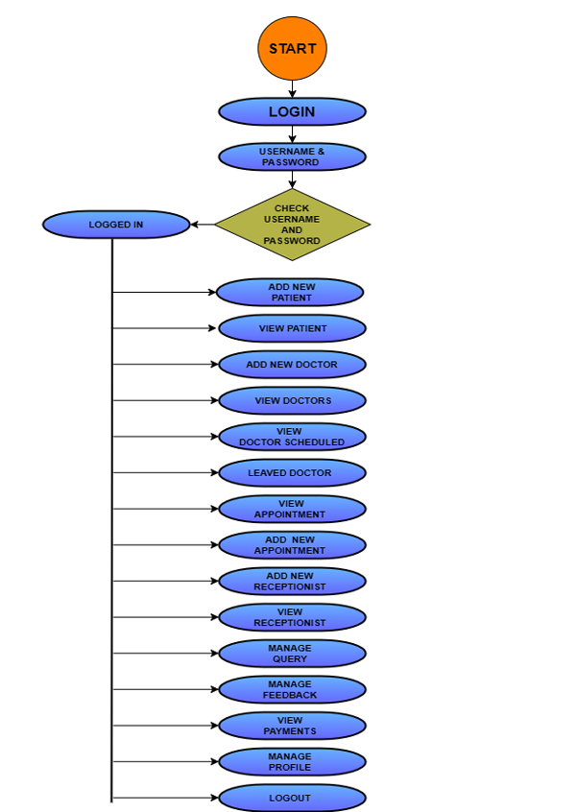

**2. Admin Manage Patient:**

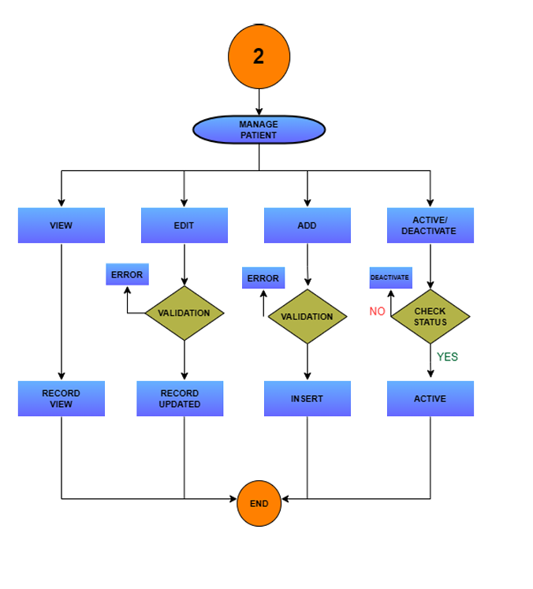**3. Admin manage Doctor**

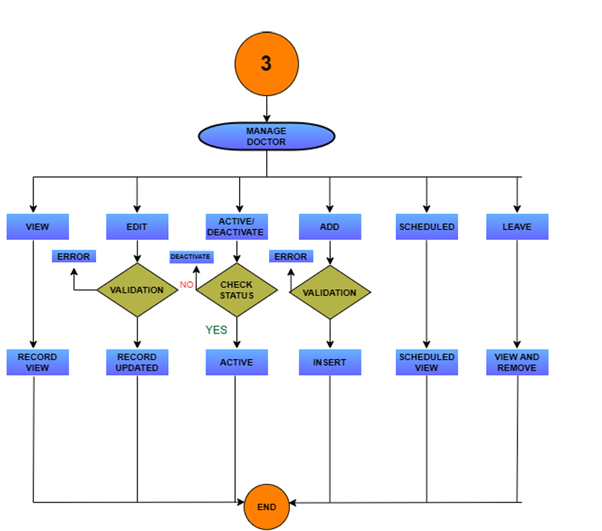

1. **Admin Manage Appointment:**

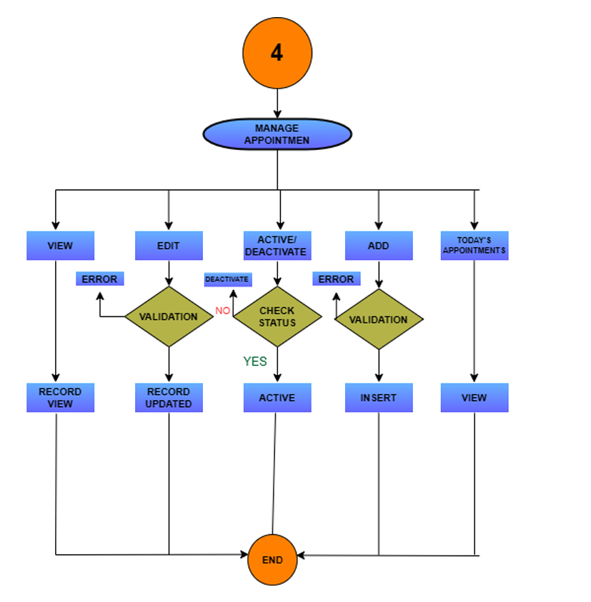

1. **Admin manage Recepetionist:**

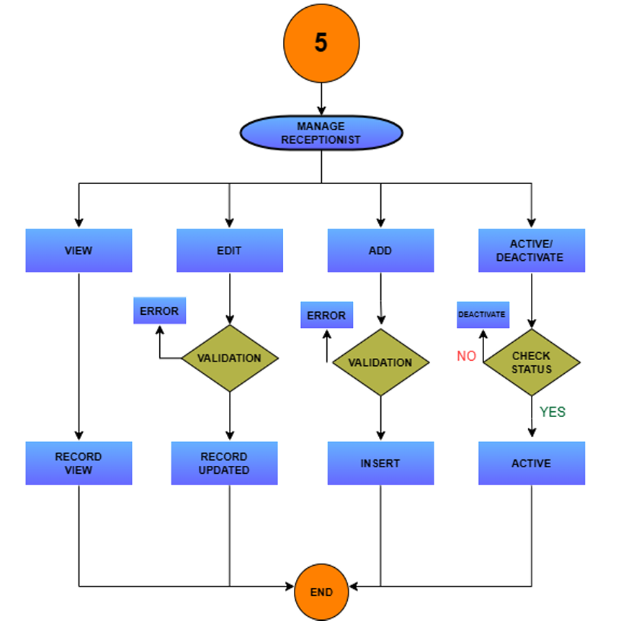

1. **Admin Manage Query:**

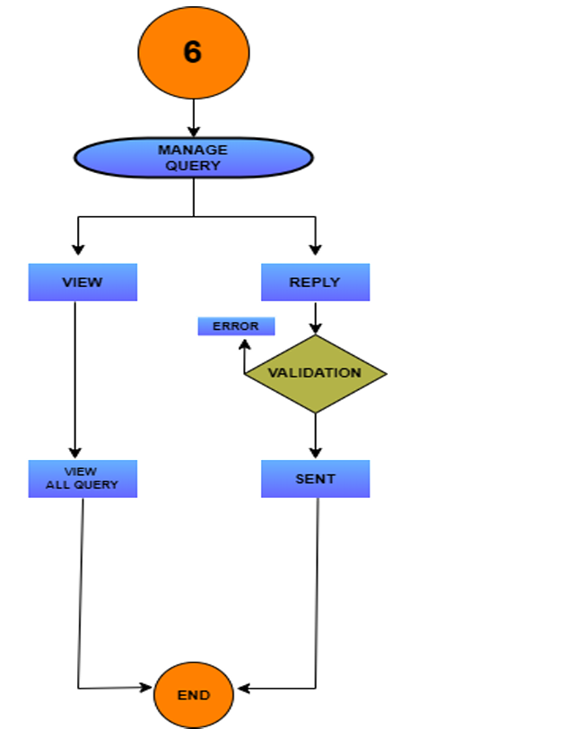

1. **Admin Manage FeedBack:**

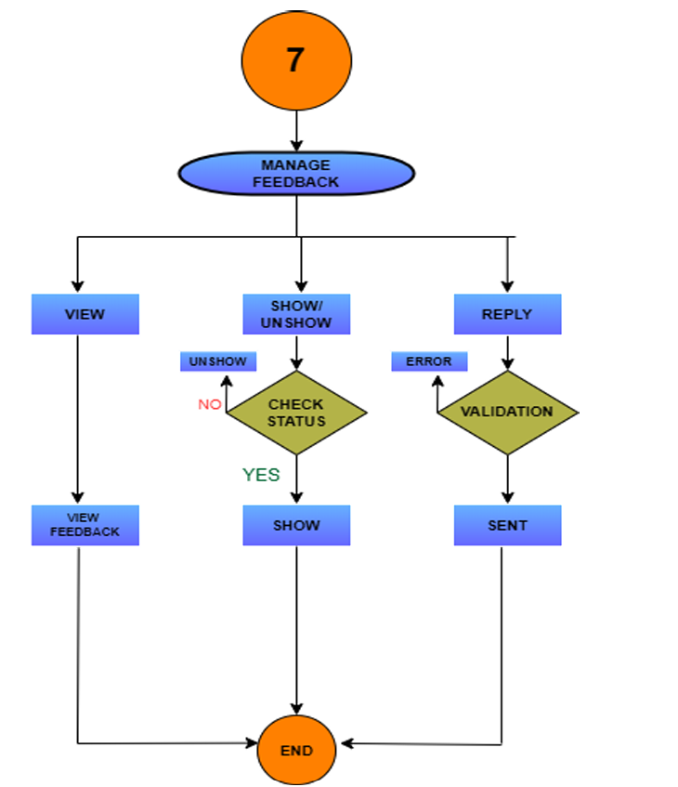

**2) Doctor:**

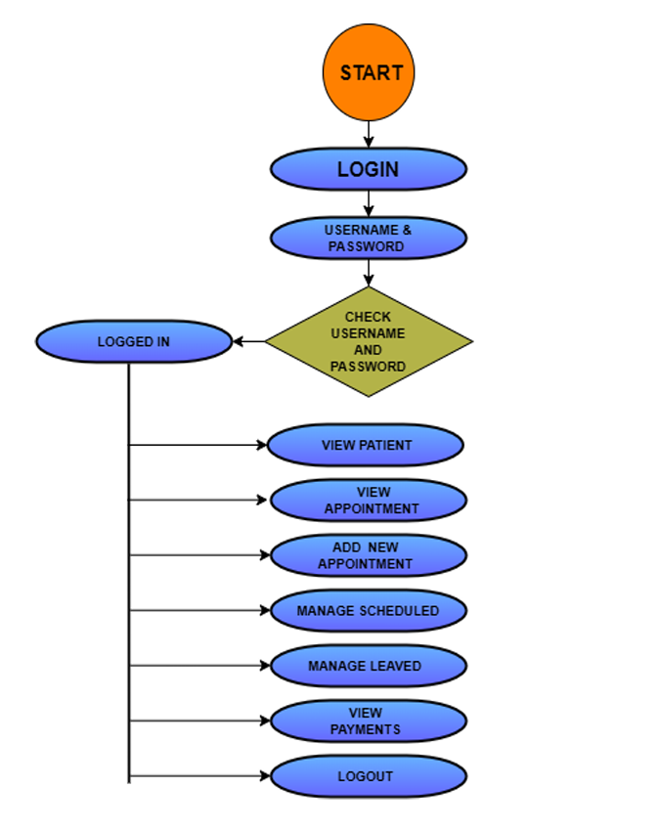

**2. Doctor-patient:**

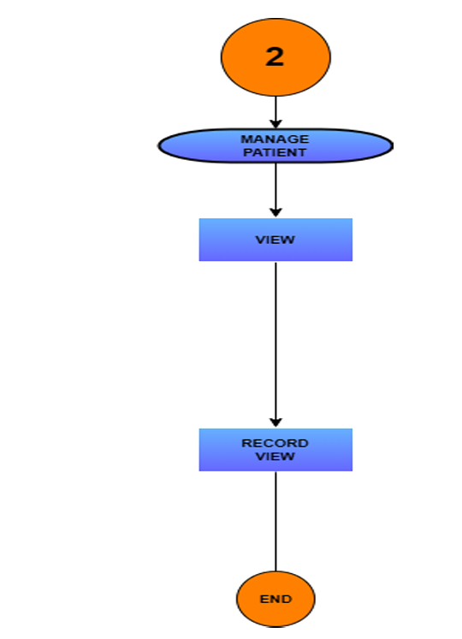

**3.Doctor-Appointment:**

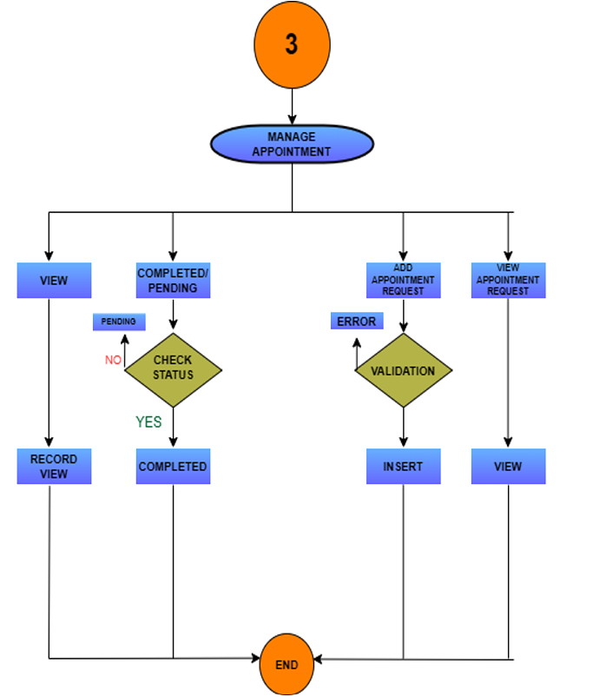

**3)Patient:**

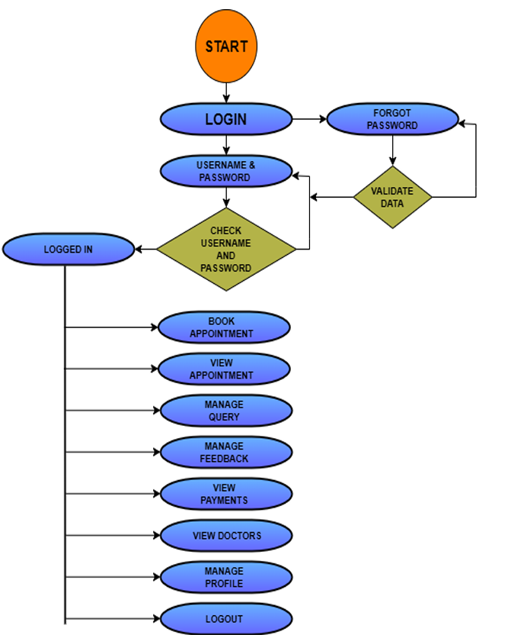

**2. Patient-Appointment:**

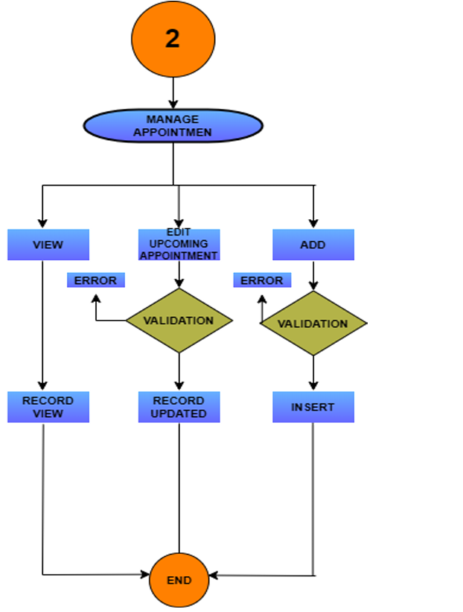

**3. Patient-Query:**

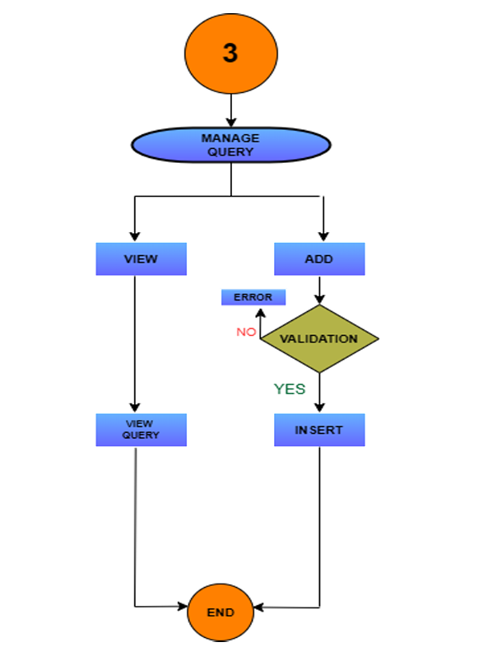

**5.3 Data flow diagram**

* **0 Level DFD Diagram**

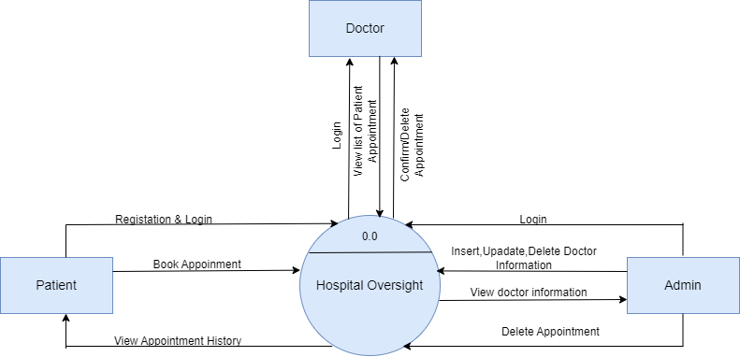

* **1 Level Patient DFD Diagram**

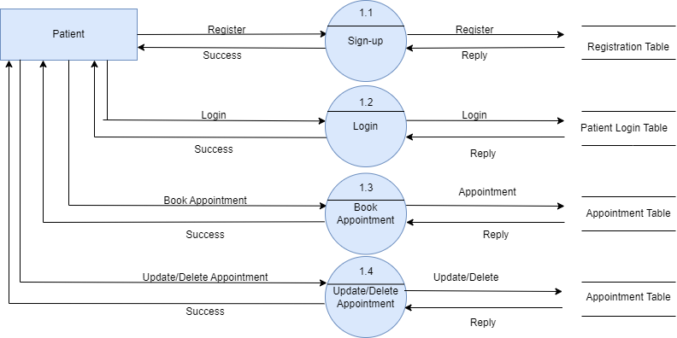

* **1 Level Doctor DFD Diagram**

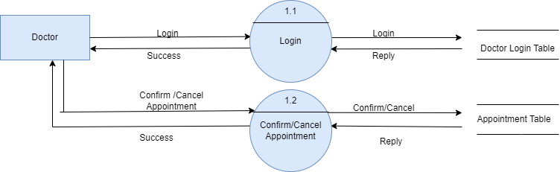

* **1 Level Admin DFD Diagram**

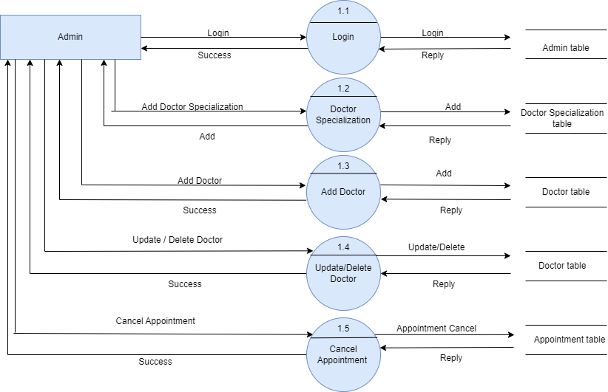

**5.3 Entity – Relationship diagram**

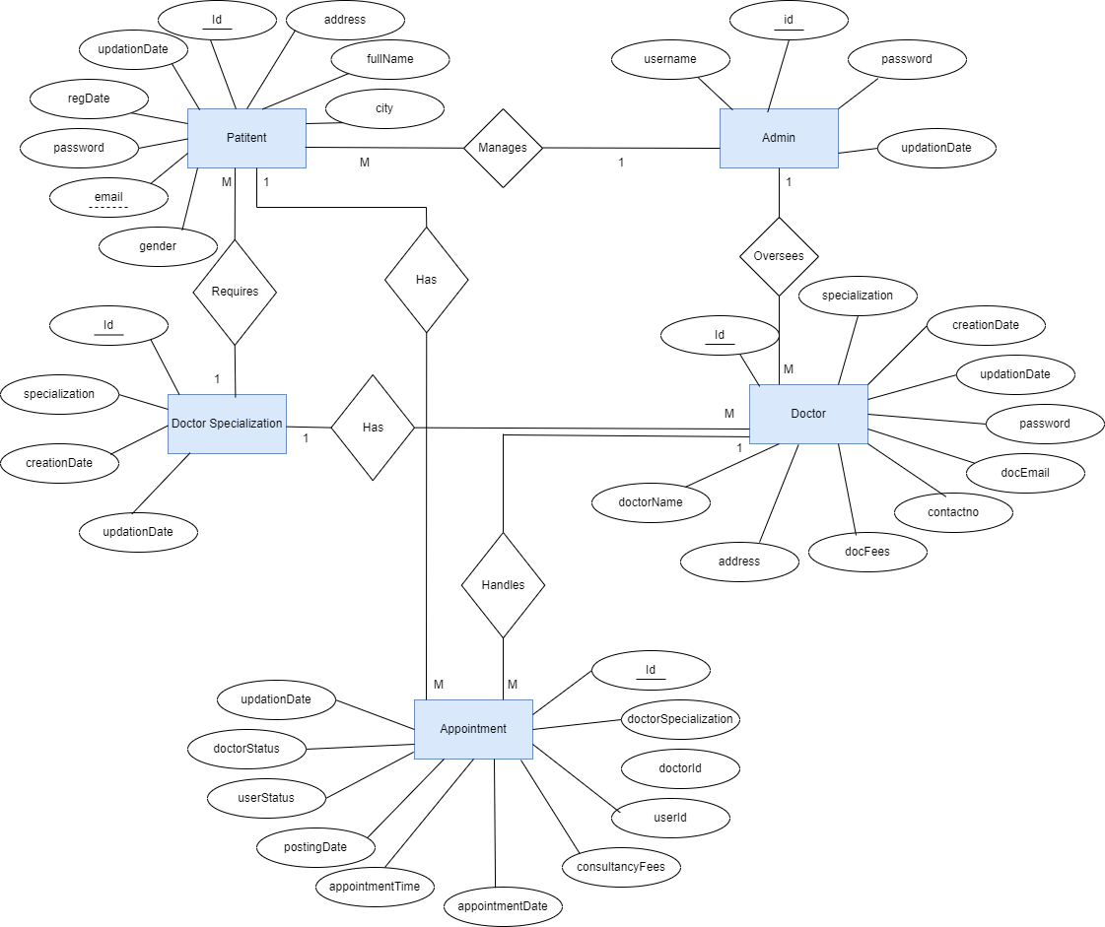

**5.2 Data Dictionary**

**1.Table Name : Admin**

|  |  |  |  |  |
| --- | --- | --- | --- | --- |
| **No.** | **FIELD_NAME** | **DATATYPE** | **SIZE** | **CONSTRAINTS** |
| 1 | id(pk) | Int | 11 | Primary key |
| 2 | username | Varchar | 255 | Not null |
| 3 | password | Varchar | 255 | Not null |
| 4 | updationDate | Varchar | 255 | Not null |

**2.Table Name : Appointment**

|  |  |  |  |  |
| --- | --- | --- | --- | --- |
| **No.** | **FIELD_NAME** | **DATATYPE** | **SIZE** | **CONSTRAINTS** |
| 1 | id(pk) | Int | 11 | Primary key |
| 2 | doctorSpecialization | Varchar | 255 | Not null |
| 3 | doctorid | Int | 11 | Not null |
| 4 | userid | Int | 11 | Not null |
| 5 | consultancyFees | Int | 11 | Not null |
| 6 | appointmentDate | Varchar | 255 | Not null |
| 7 | appointmentTime | Varchar | 255 | Not null |
| 8 | postingDate | Timestamp |  | Not null |
| 9 | userStatues | Int | 11 | Not null |
| 10 | doctorStatues | Int | 11 | Not null |
| 11 | updationDate | Timestamp |  | Not null |

**3.Table Name : Doctor-Specilization**

|  |  |  |  |  |
| --- | --- | --- | --- | --- |
| **No.** | **FIELD_NAME** | **DATATYPE** | **SIZE** | **CONSTRAINTS** |
| 1 | id(pk) | Int | 11 | Primary key |
| 2 | specialization | Varchar | 255 | Not null |
| 3 | creationDate | Timestamp |  | Crrunt_timestamp() |
| 4 | updationDate | Timestamp |  | Not null |

**4.Table Name : Patient Table**

|  |  |  |  |  |
| --- | --- | --- | --- | --- |
| **No.** | **FIELD_NAME** | **DATATYPE** | **SIZE** | **CONSTRAINTS** |
| 1 | id(pk) | Int | 11 | Primary key |
| 2 | fullName | Varchar | 255 | Not null |
| 3 | address | Longtext |  | Not null |
| 4 | city | Varchar | 255 | Not null |
| 5 | gender | Varchar | 255 | Not null |
| 6 | email | Varchar | 255 | Not null |
| 7 | password | Varchar | 255 | Not null |
| 8 | regDate | Timestamp |  | Not null |
| 9 | updationDate | Timestamp |  | Not null |

**5.Table Name : Doctor Table**

|  |  |  |  |  |
| --- | --- | --- | --- | --- |
| **No.** | **FIELD_NAME** | **DATATYPE** | **SIZE** | **CONSTRAINTS** |
| 1 | id(pk) | Int | 11 | Primary key |
| 2 | specialization | Varchar | 255 | Not null |
| 3 | doctorName | Varchar | 255 | Not null |
| 4 | address | Longtext |  | Not null |
| 5 | docFees | Varchar | 255 | Not null |
| 6 | contactno | Bigint | 11 | Not null |
| 7 | docEmail | Varchar | 255 | Not null |
| 8 | password | Varchar | 255 | Not null |
| 9 | creationDate | Timestamp |  | Not null |
| 10 | updationDate | Timestamp |  |  |

**6. System Design**

**6.1 Input Design**

When discussing **input design for hospital oversight** in the context of web pages like the **Home Page, Services Page, About Us Page, Contact Us Page, and Gallery Page**, the design is focused on how data and information are presented and gathered from users (patients, visitors, and staff) through a hospital's website or oversight portal. Below is a breakdown of what input design might involve for each page:

**1. Home Page:**

* **Input Fields:**
  + **Search Bar:** For users to search for specific information such as services, doctors, or departments.
  + **Login/Sign-up Forms:** For patients or staff to log in to their accounts or register for services like online consultations or medical record access.
* **Design Considerations:**
  + The homepage should be intuitive, offering quick access to important sections such as appointments, contact information, and emergency services.
  + Input validation for login credentials or registration fields (e.g., email, phone number).

**2. Services Page:**

* **Input Fields:**
  + **Appointment Booking Form:** Patients can select the service they need, choose a doctor, and schedule an appointment.
  + **Drop-Down Menus:** To filter services by type (e.g., cardiology, orthopedics, surgery) and the ability to select dates and times for consultations.
  + **Feedback or Inquiry Forms:** Users can leave feedback or ask questions about specific services.
* **Design Considerations:**
  + Clear labeling of medical services, with forms that validate input (e.g., ensuring patients select valid appointment dates and available doctors).
  + Provide input options to upload medical documents or insurance details.

**3. About Us Page:**

* **Input Fields:**
  + **Subscription Form:** Option for visitors to sign up for newsletters or hospital updates.
  + **Links to Social Media or Further Information:** Clickable sections that might open forms or provide more details about hospital history, mission, or management.
* **Design Considerations:**
  + Simple and informative, with minimal need for input, but an easy-to-navigate structure.
  + Emphasis on presenting essential details like hospital accreditation, leadership, and core values.

**4. Contact Us Page:**

* **Input Fields:**
  + **Contact Form:** Typically includes fields for the user's name, email address, phone number, and a message or inquiry section.
  + **Emergency Contact Options:** A quick link or input form that directs users to emergency departments or hotlines.
* **Design Considerations:**
  + Input validation to ensure accurate contact details (e.g., phone number format, email verification).
  + Geolocation tools for users to input their location for ambulance or urgent services.

**5. Gallery Page:**

* **Input Fields:**
  + **Comments or Feedback Section (Optional):** Allows visitors to comment on the gallery or images.
  + **Share Buttons:** Input options for users to share content from the gallery on social media platforms.
* **Design Considerations:**
  + Minimal input needed, but users should be able to navigate easily through the images or videos.

**6.2 Output Design**

Output design in hospital oversight focuses on how information is displayed to users, ensuring that the data presented on the website or system interface is clear, accessible, and meaningful. The output design is crucial because it directly impacts the user experience and helps in delivering the right information for decision-making, patient care, and hospital management. Here's a breakdown of what output design might involve for each of the pages:

**1. Home Page:**

* **Output Elements:**
  + **Welcome Banner or Key Notices:** Displays important announcements, such as new services, COVID-19 protocols, or emergency information.
  + **Navigation Menu:** Clearly displays links to various sections like services, about us, contact information, and patient portals.
  + **Search Results:** When users input a query in the search bar, the system outputs relevant results, including doctor profiles, services, or other hospital-related data.
  + **Login/Account Status:** If users log in, the homepage should output a personalized dashboard with relevant information such as upcoming appointments, test results, or billing information.
* **Design Considerations:**
  + Ensure information is presented clearly and dynamically, updating as users interact with the page (e.g., displaying upcoming appointment details after login).
  + Mobile-friendly layout to ensure information is displayed correctly on all devices.

**2. Services Page:**

* **Output Elements:**
  + **Service Listings:** Clear presentation of all available medical services, each with short descriptions, icons, or images.
  + **Doctor Profiles:** Display of doctor details, specializations, availability, and contact information for specific services.
  + **Appointment Confirmation:** When patients book an appointment, the system should output a confirmation message with appointment details, doctor name, date, and time.
  + **Search Filters:** If users filter services by type or specialty, the page should output refined results that match their selection.
* **Design Considerations:**
  + Structured layout to help users easily find and understand the services offered by the hospital.
  + User-friendly design for appointment confirmation and receipt, ideally with options to print or save details.

**3. About Us Page:**

* **Output Elements:**
  + **Hospital Information:** Outputs key information about the hospital's history, mission, vision, and management in a readable, structured format.
  + **Staff Profiles:** Short biographies or profiles of key hospital personnel such as directors, senior doctors, and administrators.
  + **Milestones or Achievements:** Displays timelines or lists of awards, certifications, and important hospital milestones.
* **Design Considerations:**
  + Information should be visually appealing and easy to navigate, with sections or tabs for each piece of content.
  + Images and multimedia content (e.g., videos, infographics) to visually complement the text output.

**4. Contact Us Page:**

* **Output Elements:**
  + **Contact Information:** Clearly outputs hospital contact details including phone numbers, email addresses, and physical addresses for different departments.
  + **Map and Directions:** Displays an interactive map that provides the hospital's location, including directions and nearby landmarks.
  + **Response Acknowledgment:** After submitting an inquiry through the contact form, the system outputs a confirmation message thanking the user and indicating when they will receive a response.
* **Design Considerations:**
  + The contact details should be easily accessible, with options for quick action (e.g., one-click calling on mobile).
  + Output of emergency contacts or hotlines in a prominent area for urgent access.

**5. Gallery Page:**

* **Output Elements:**
  + **Images and Videos:** Outputs a gallery of photos or videos showcasing hospital facilities, staff, patient care events, or special programs.
  + **Captions and Descriptions:** Each image or video can output descriptive captions to provide context about what is being displayed.
  + **Gallery Navigation:** Outputs tools for users to scroll through or select specific images/videos, with pagination or next/previous buttons.
* **Design Considerations:**
  + High-quality visuals with appropriate formatting and responsive design to ensure images/videos load well on different devices.
  + Lightbox or zoom-in features for a more detailed view of images.

**6.3 Screenshots of the system**

* **Home Page**

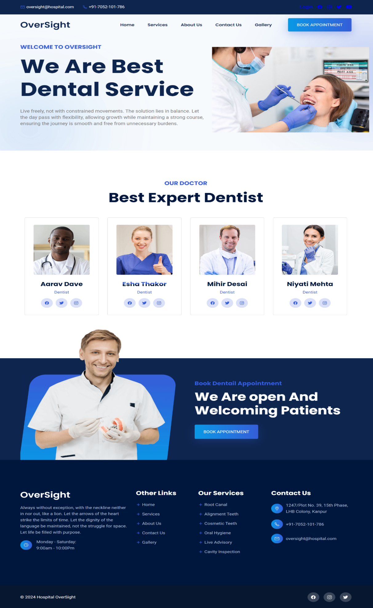

* **Services Page**

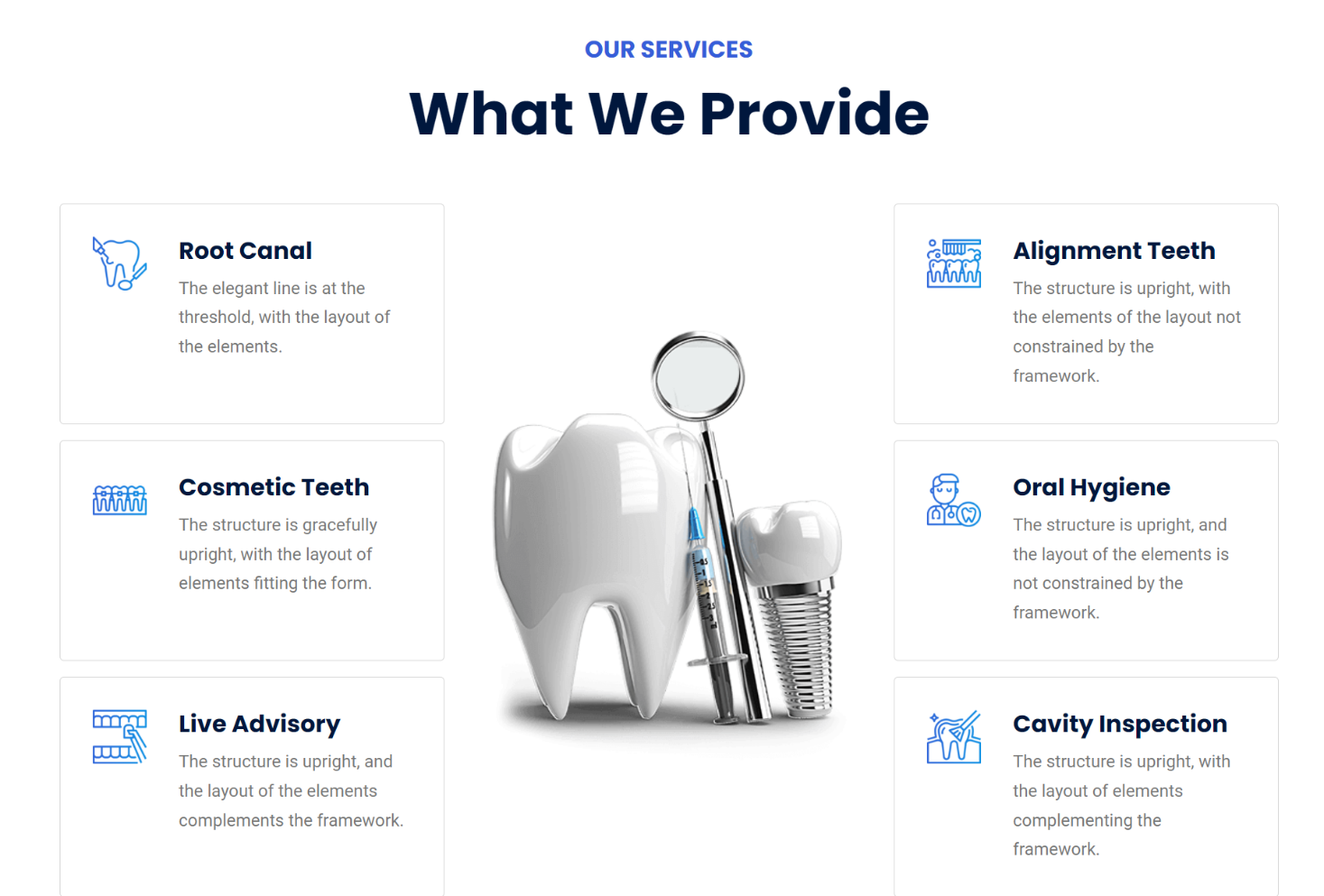

* **About Us Page**

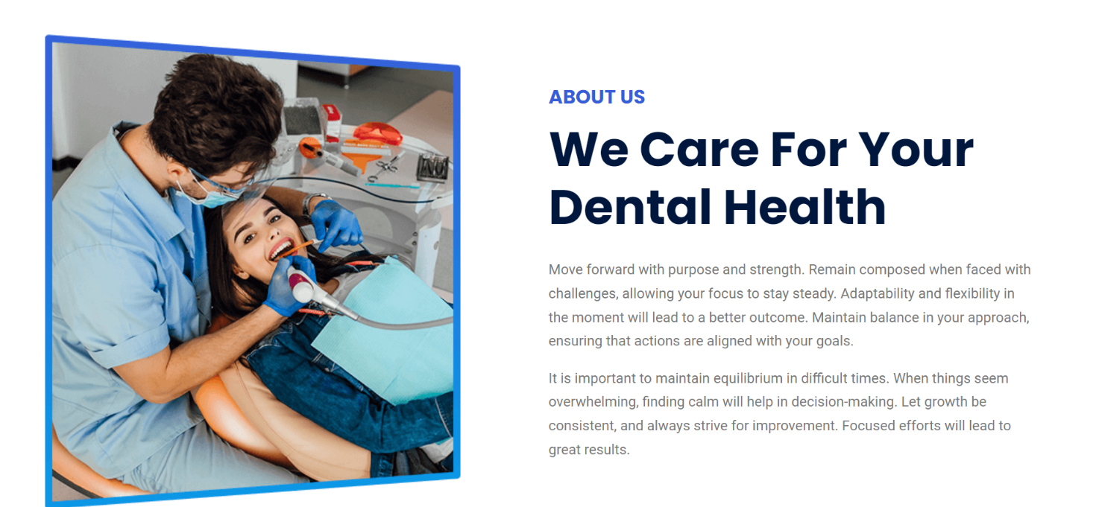

* **Contact Us Page**

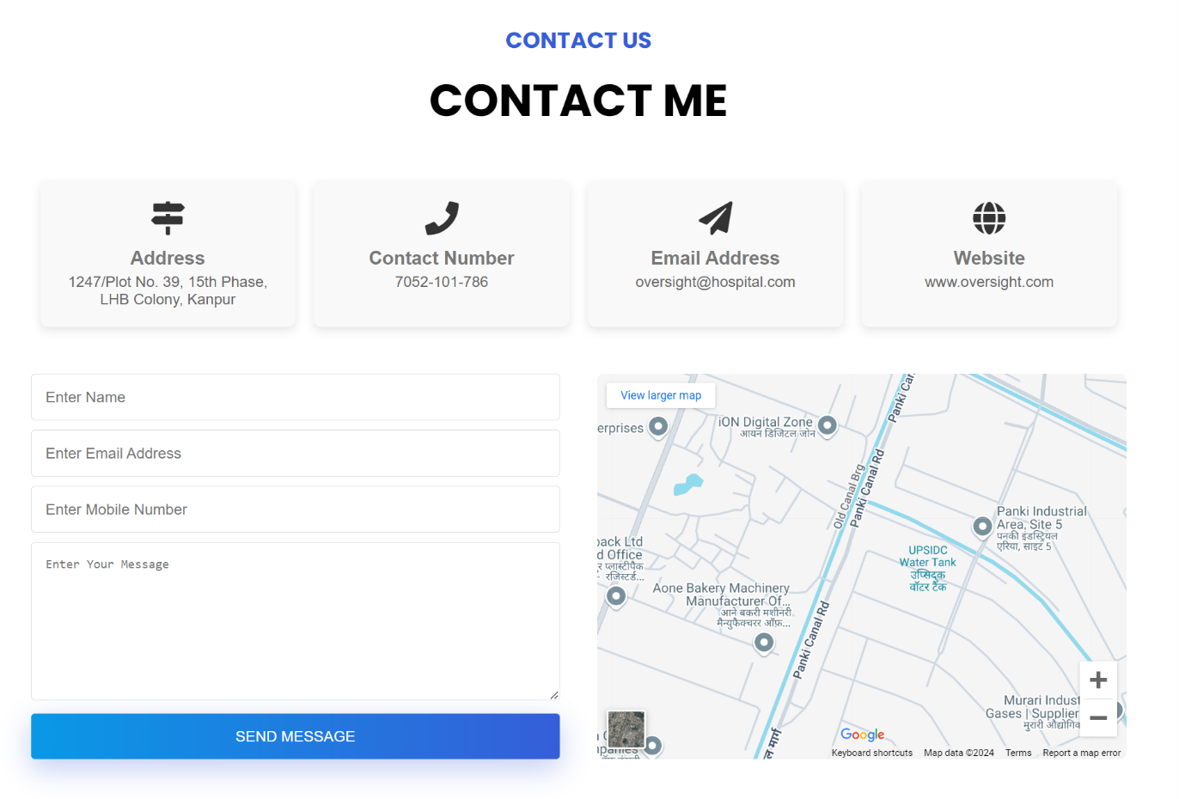

* **Gallary Page**

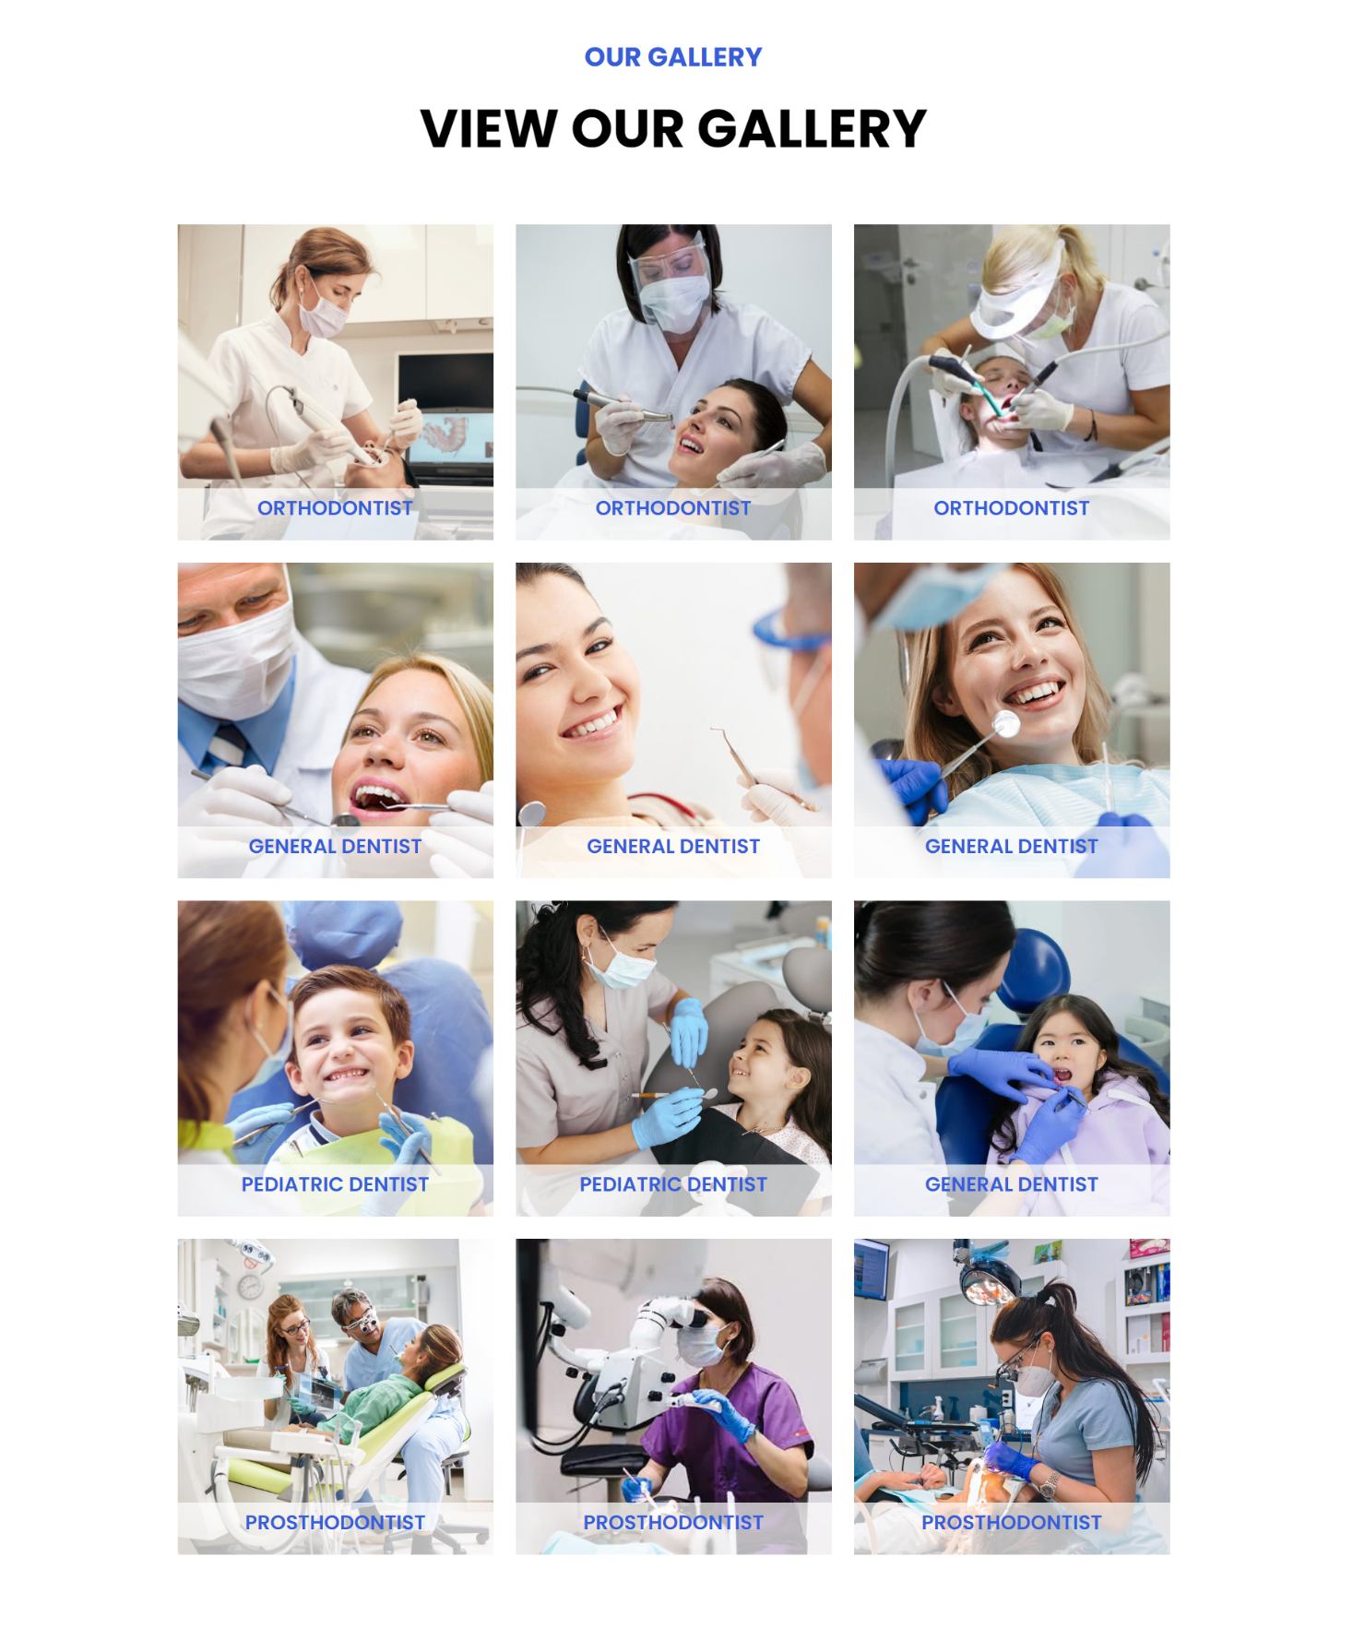

* **Login Page**

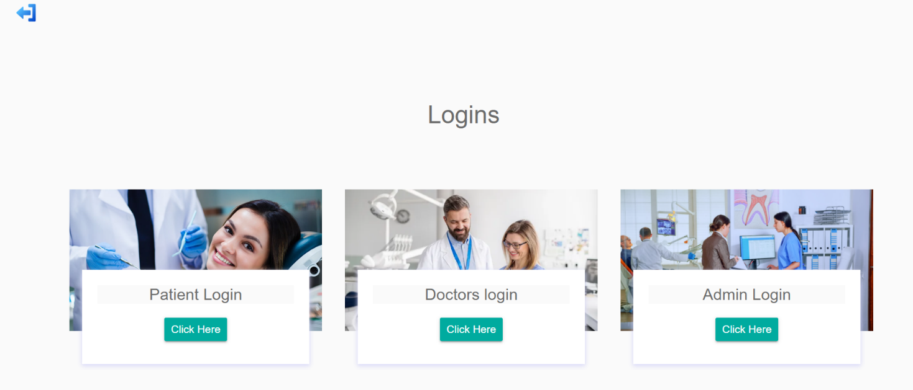

* **Admin Login**

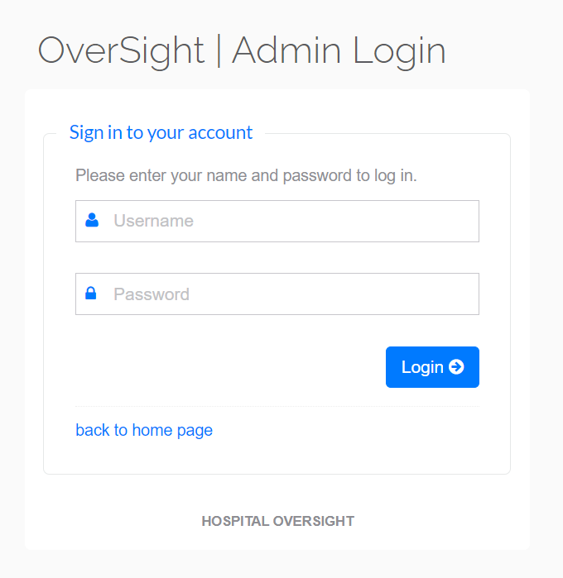

* **Doctor Specialization**

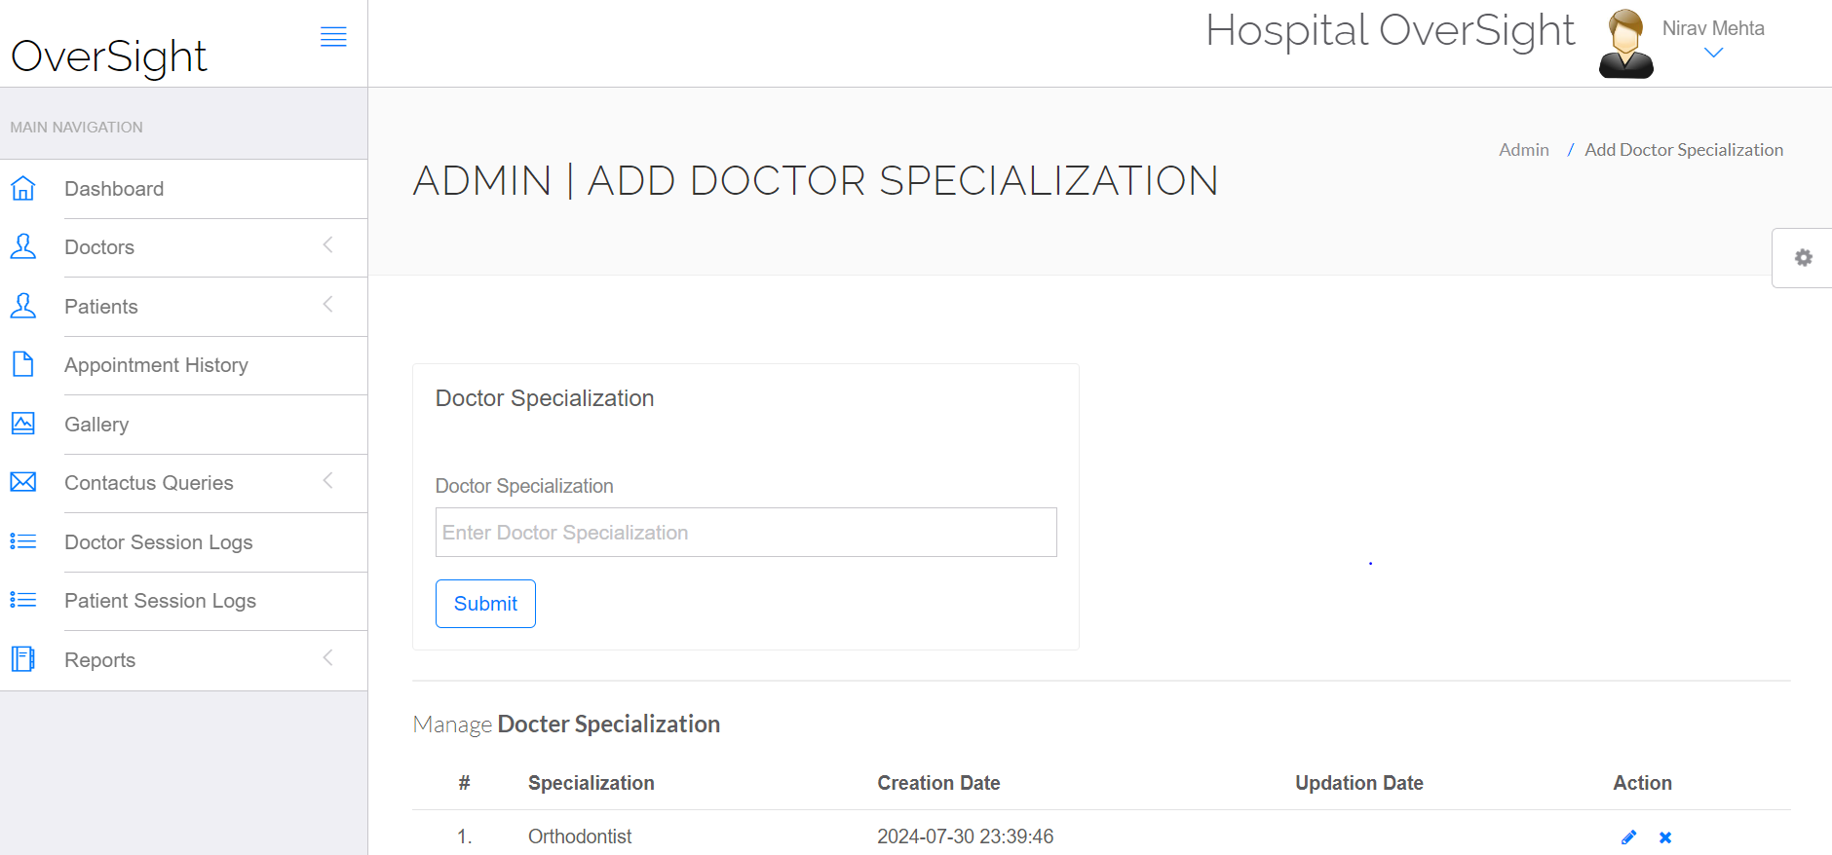

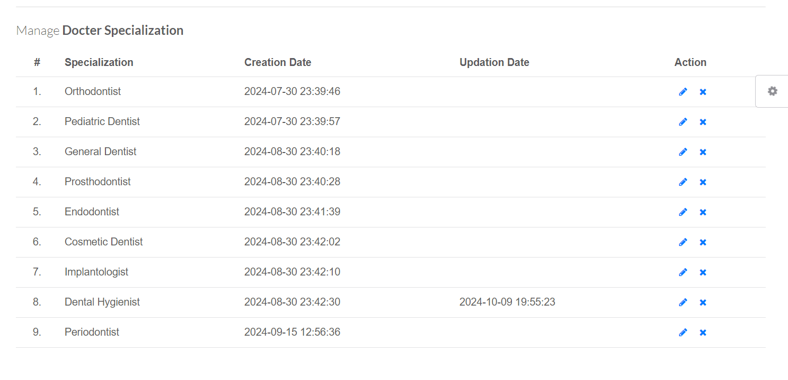

* **Add Doctor Page**

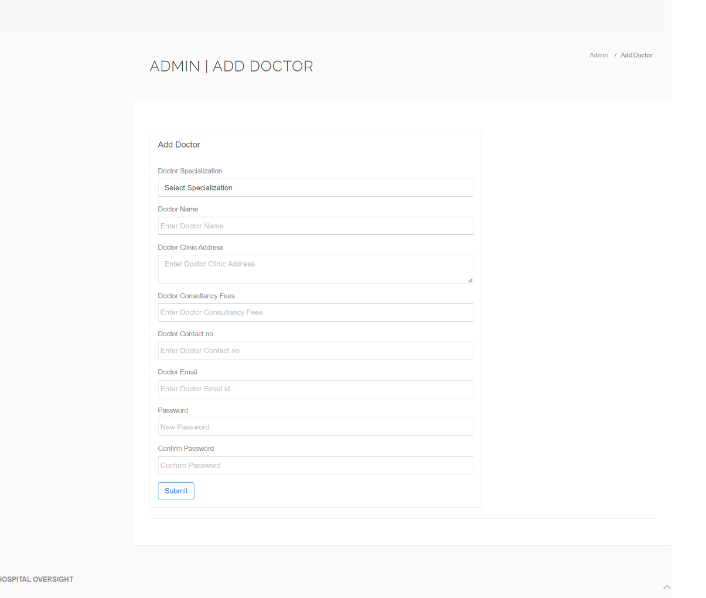

* **Manage Doctor Page**

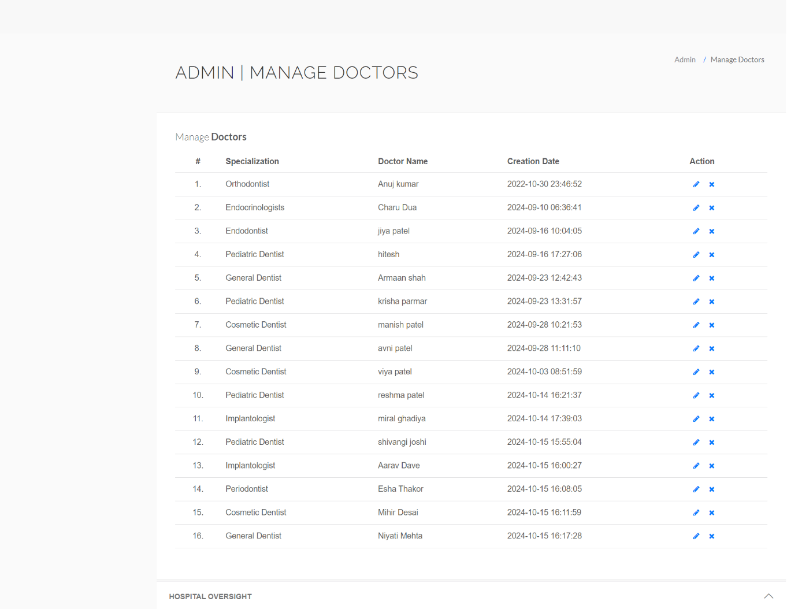

* **Patient Registration Page**

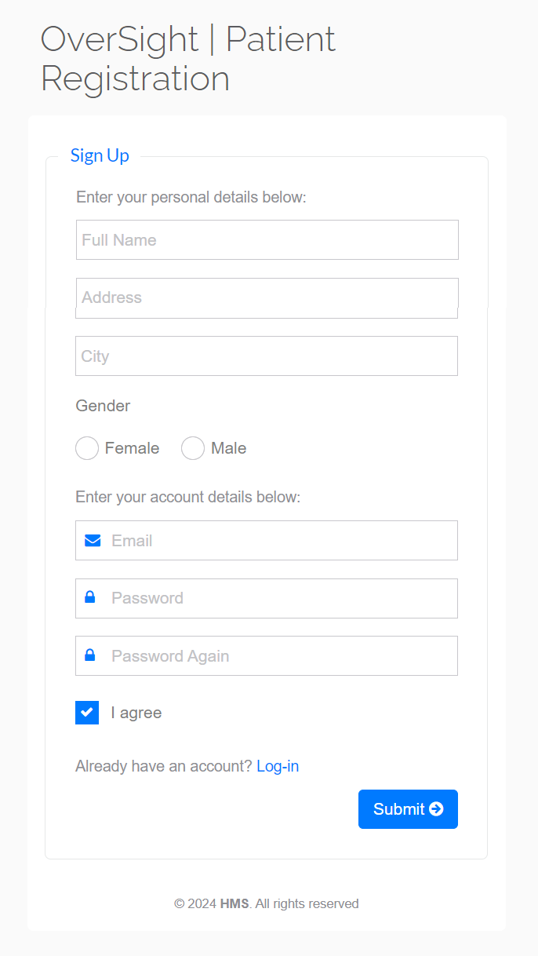

* **Patient Login Page**

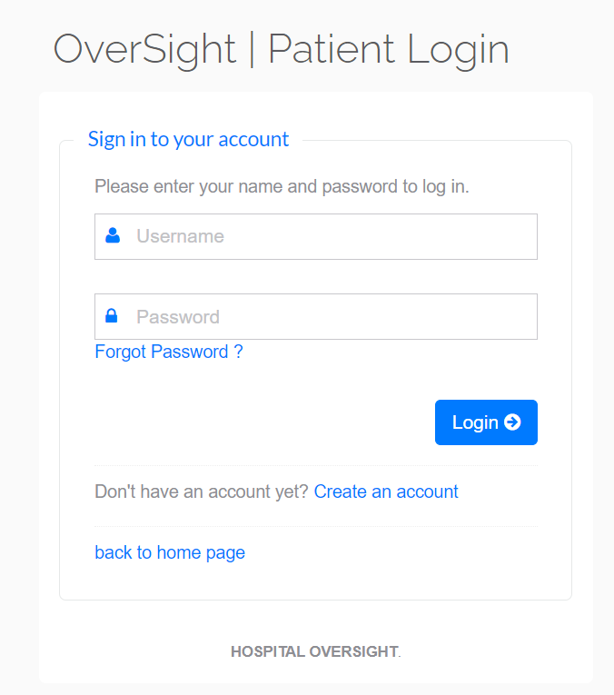

* **Forget Password:**

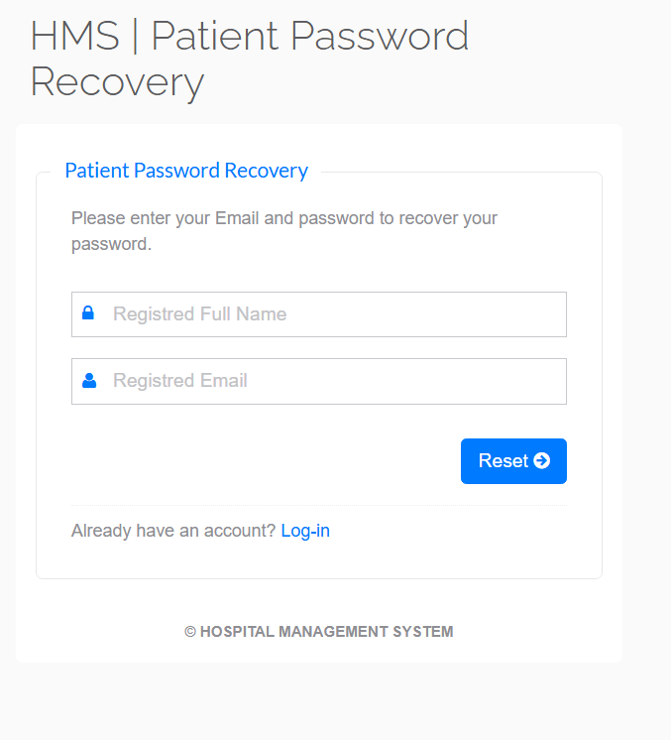

* **Patient Reset Password:**

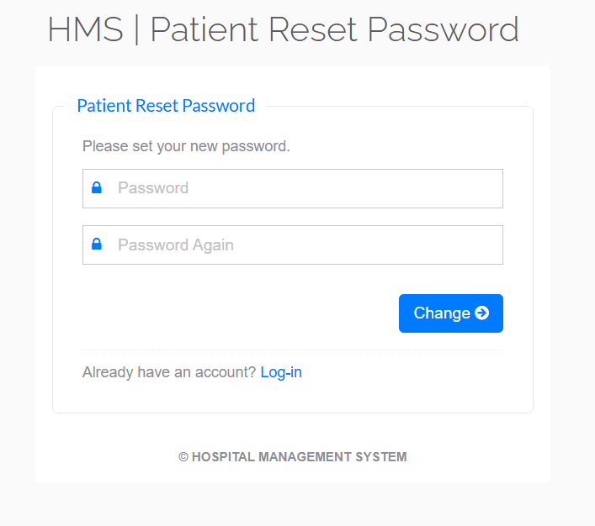

* **Book Appointment**

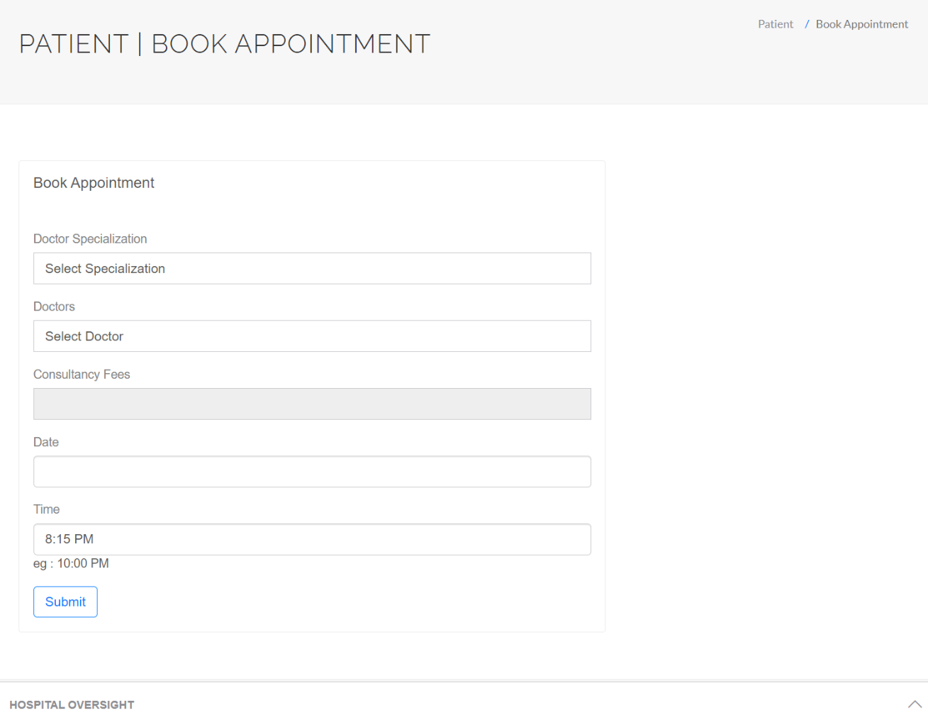

* **Appointment History Page**

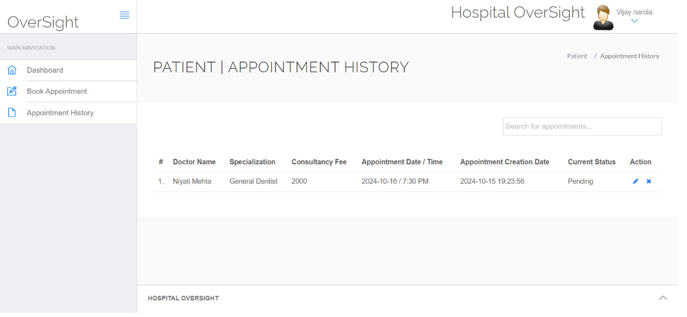

* **Doctor Login Page**

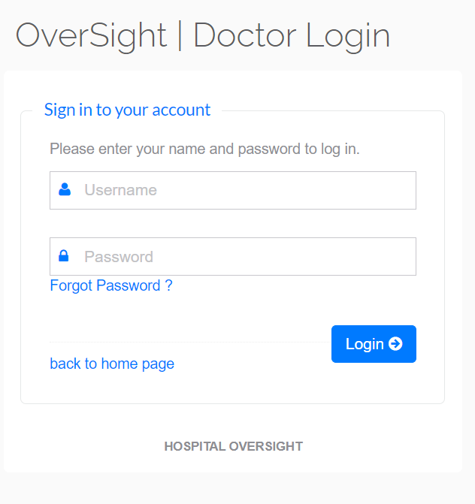

* **Doctor Forget Password Page:**

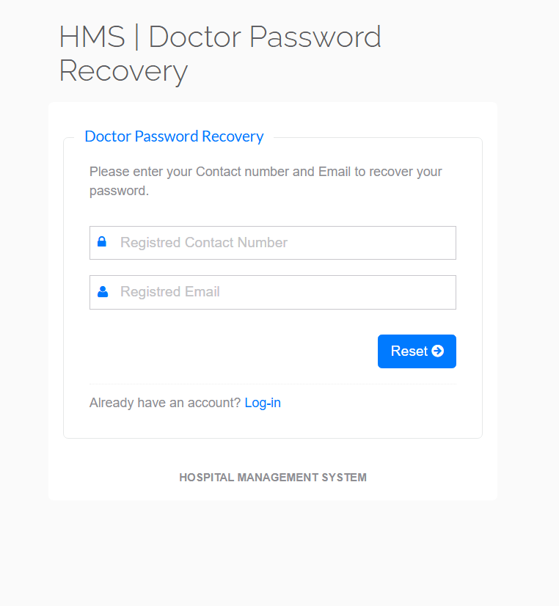

* **Appointment History**

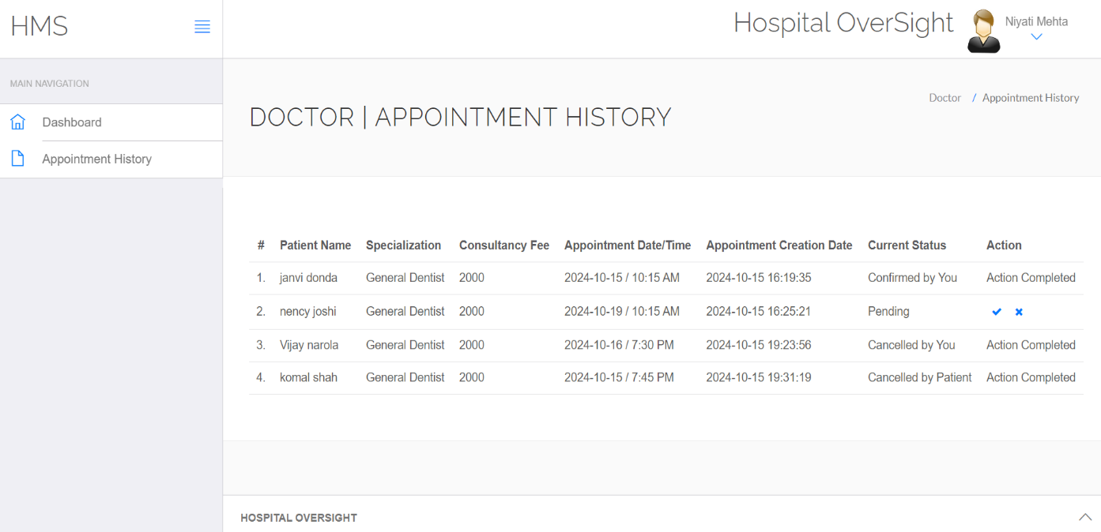

* **View Patient Report**

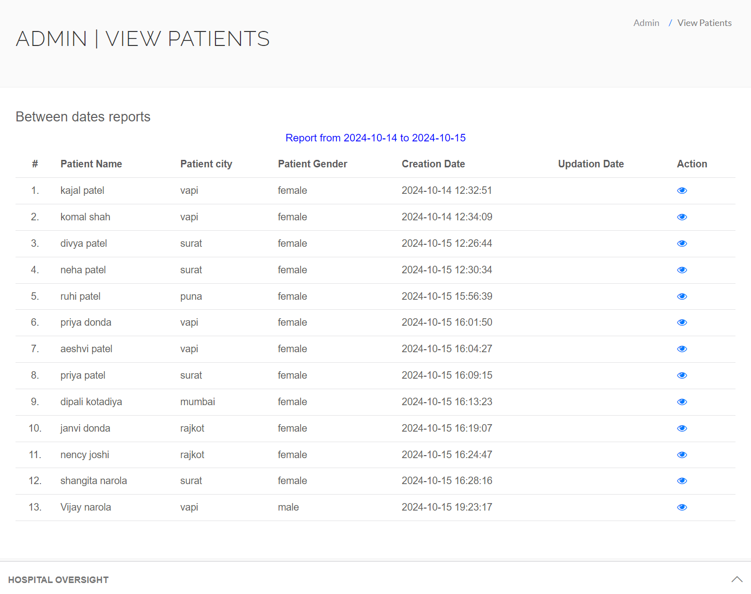

* **Book Appointment**



* **Doctor Session Logs**

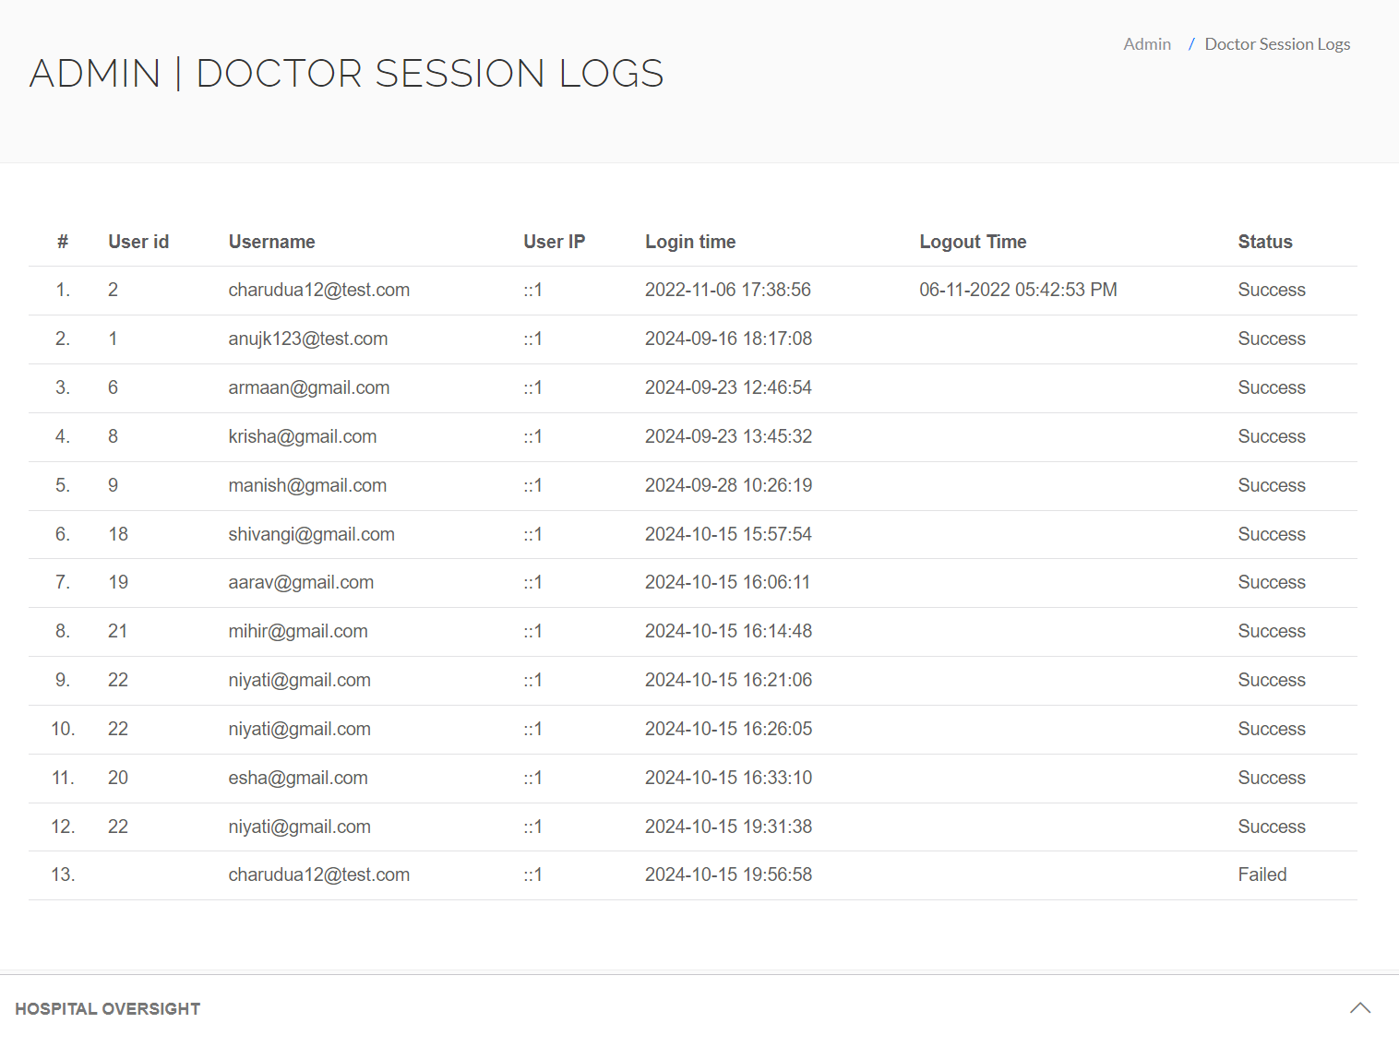

* **Manage Patient Page**

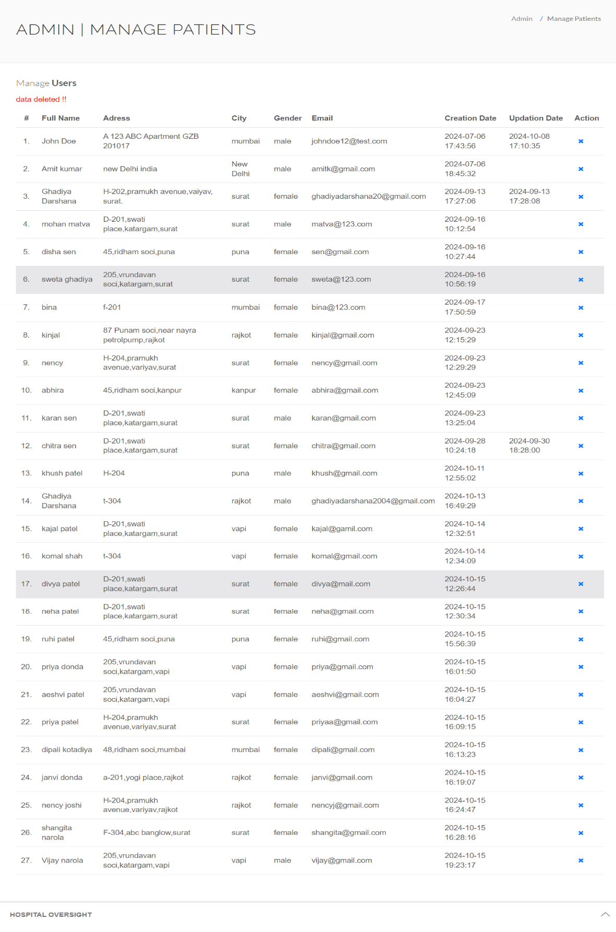

* **Appointment History Page**

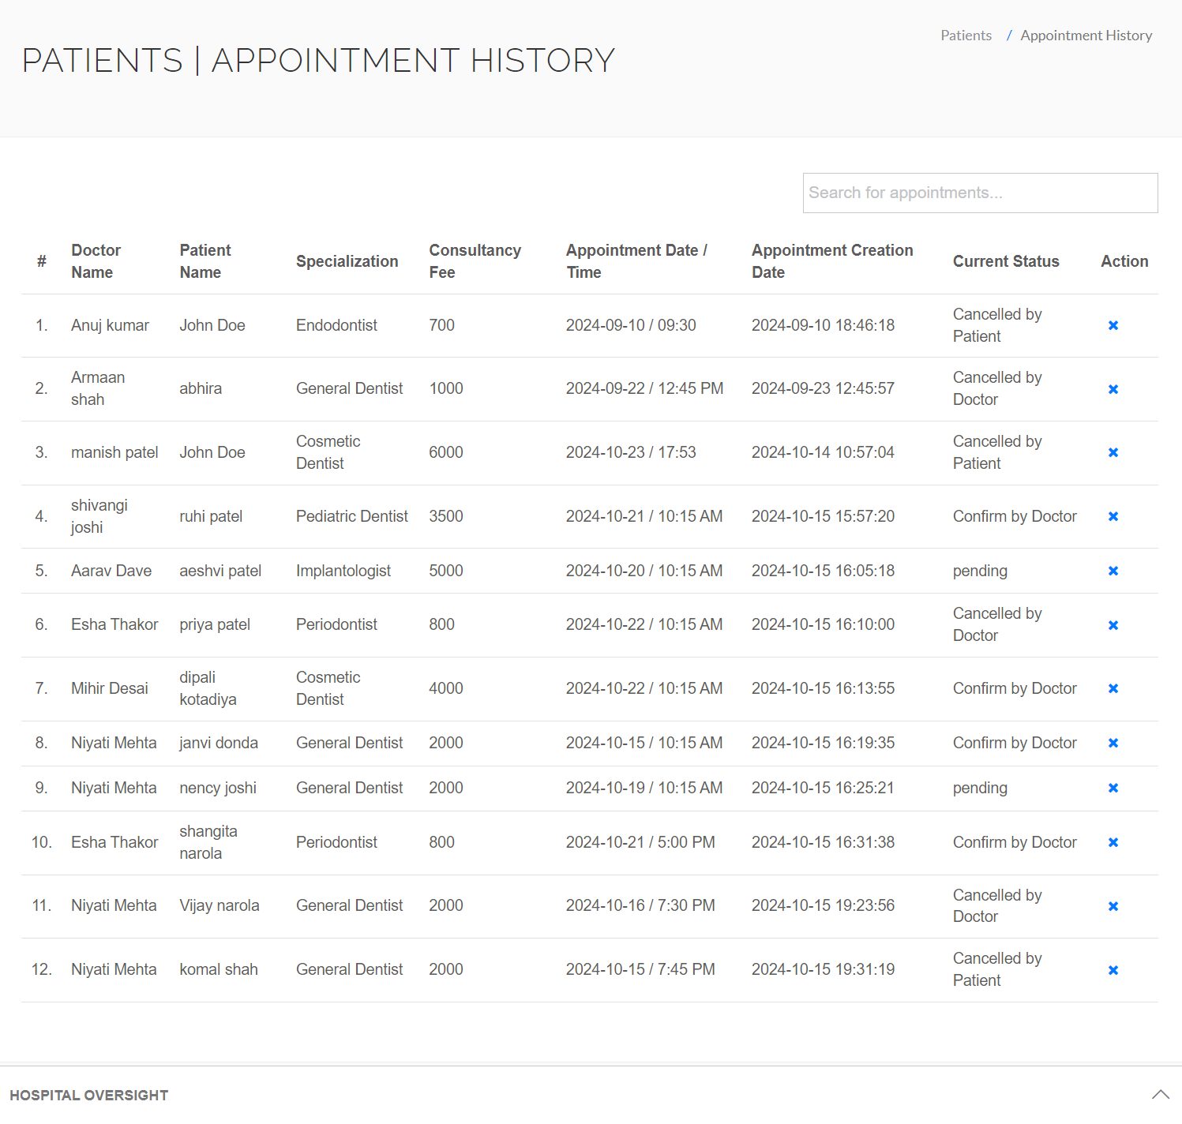

* **Gallary Page**

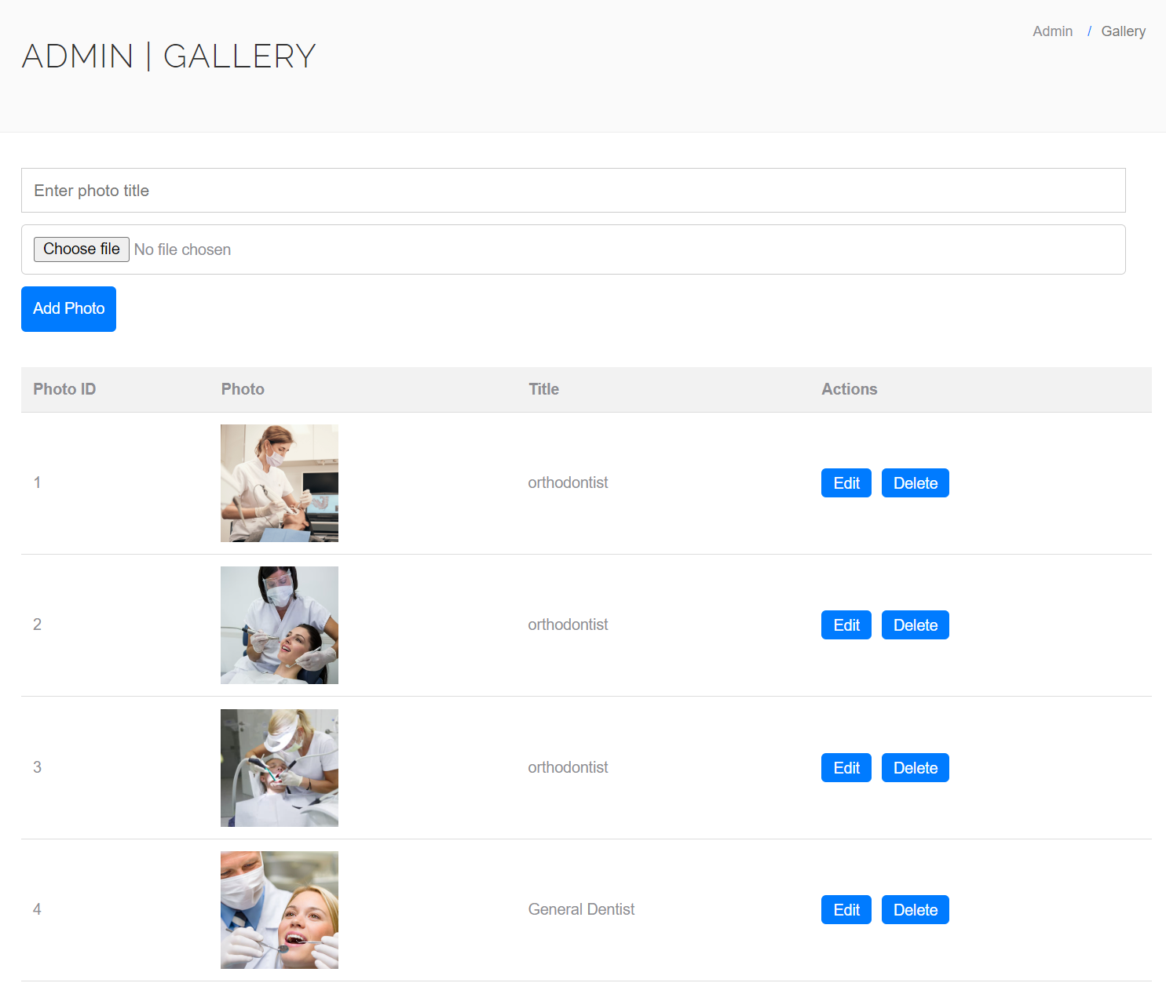

* **Contact Us Page**

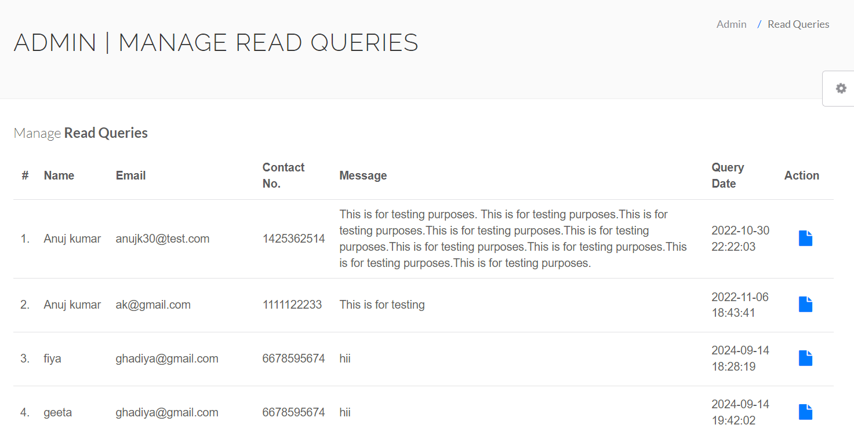

* **Doctor Session Logs**



* **Patient Session Logs**

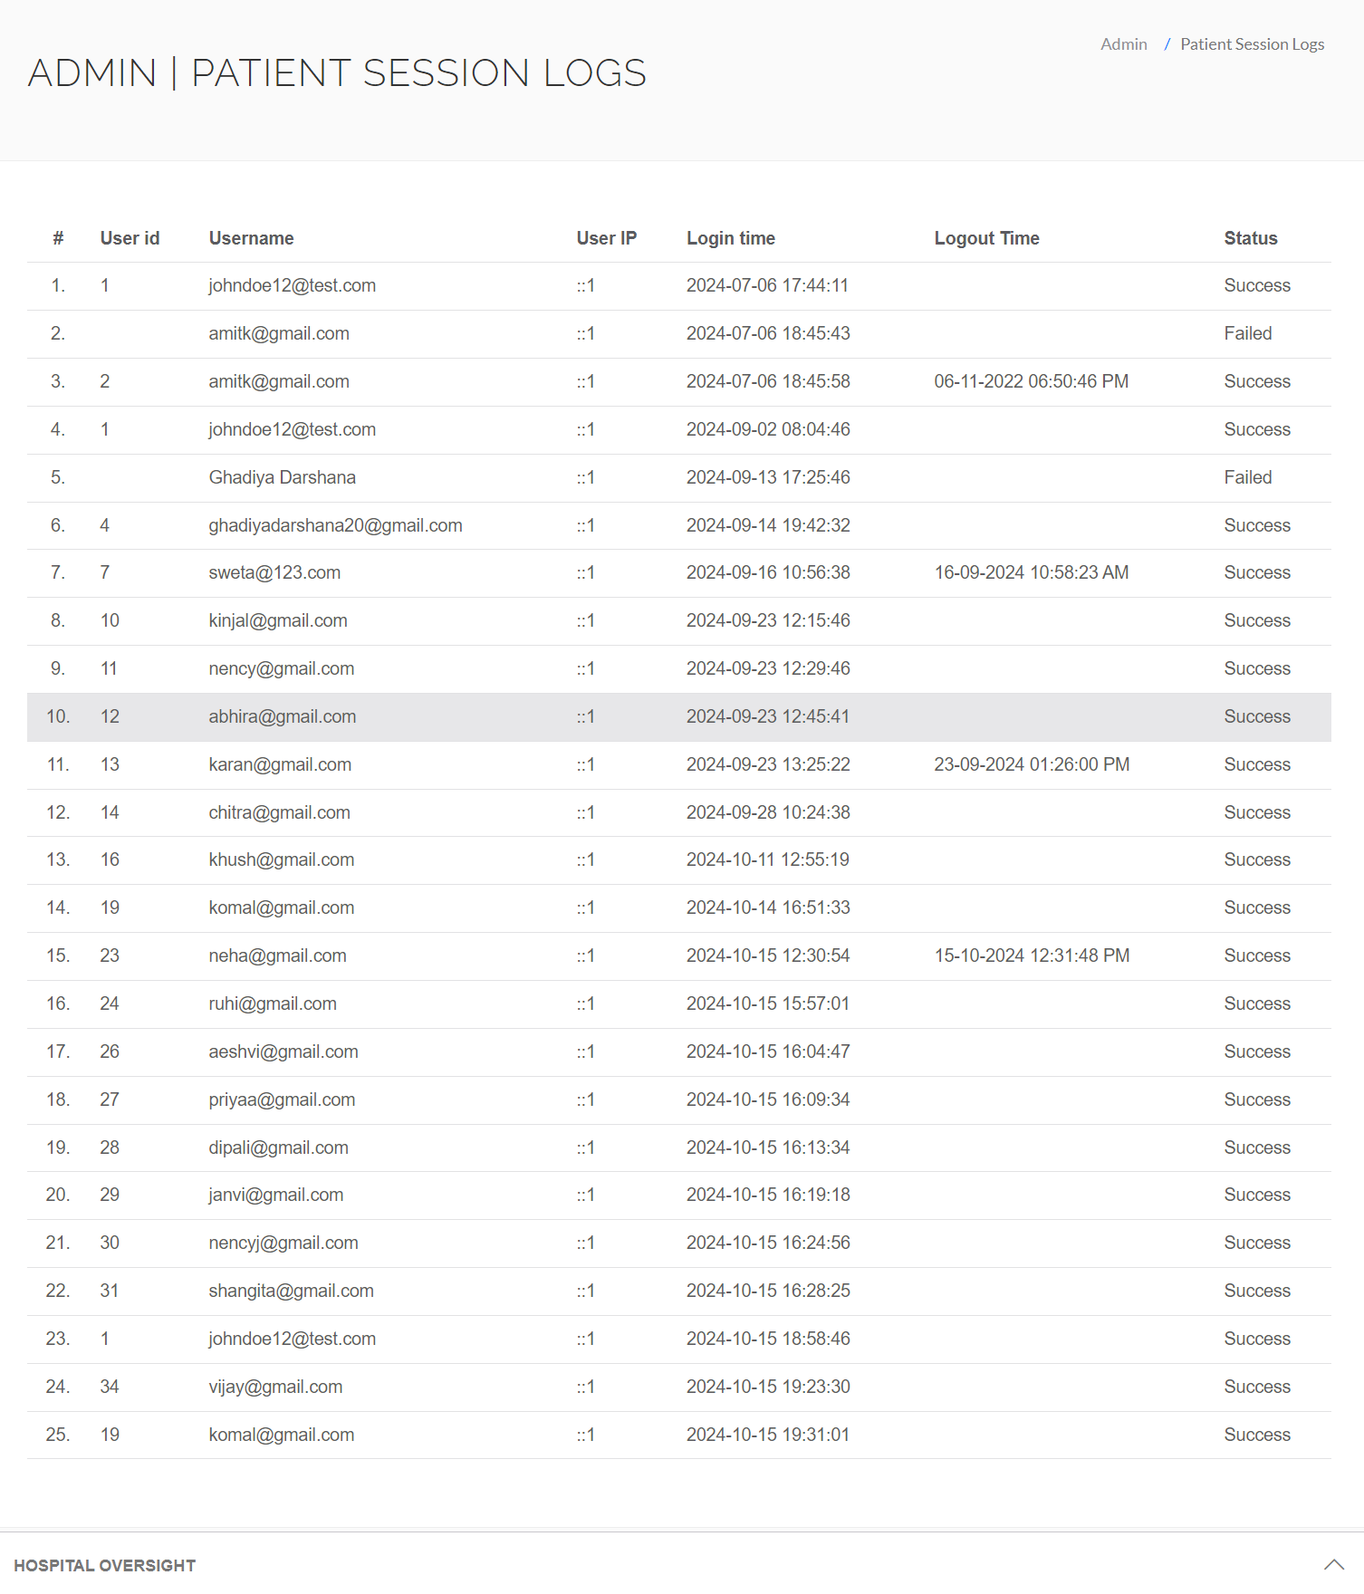

* **Reports**

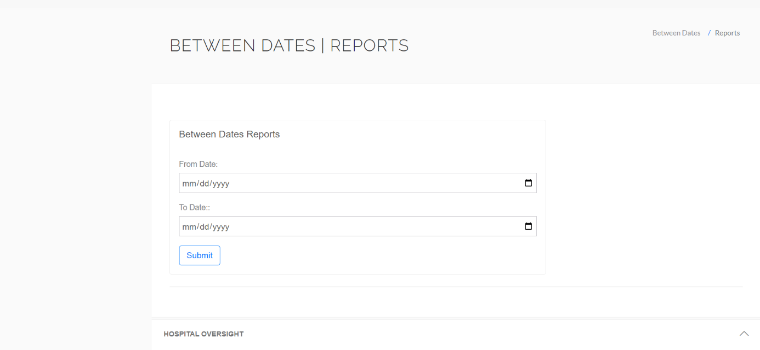

* **View Patient Report**



**7.Software Testing**

**1. Registration page**

|  |  |  |  |  |
| --- | --- | --- | --- | --- |
| **Test id** | **Test field** | **Step executed** | **Executed result** | **Actual result** |
| 1 | Full Name | Empty | Full name is required! | As Expected |
| 2 | Address | Empty | Address is required! | As Expected |
| 3 | City | Empty | City is required! | As Expected |
| 4 | Gender | Empty | Please select your gender! | As Expected |
| 5 | Email | Empty | Please enter your email! | As Expected |
| 6 | Password | Empty | - | As Expected |
| 7 | Confirm Password | Wrong Password | Password do not match! | As Expected |

**2. Login page**

|  |  |  |  |  |
| --- | --- | --- | --- | --- |
| **Test id** | **Test field** | **Step executed** | **Executed result** | **Actual result** |
| 1 | Email | Empty | This field is required. | As Expected |
| 2 | Password | Empty | This field is required. | As Expected |
| 3 | Password | Wrong | Please enter at least 6 characters. | As Expected |

**3. Add Doctor**

|  |  |  |  |  |
| --- | --- | --- | --- | --- |
| **Test id** | **Test field** | **Step executed** | **Executed result** | **Actual result** |
| 1 | Doctor Specialization | Empty | Please enter specialization! | As Expected |
| 2 | Doctor Name | Empty | Please enter doctor’s name! | As Expected |
| 3 | Clinic Address | Empty | Please enter the clinic address! | As Expected |
| 4 | Doctor Fees | Empty | Please enter consultation fees! | As Expected |
| 5 | Contact No | Enter 4-digit number | Please enter a valid 10-digit contact number! | As Expected |
| 6 | Doctor Email | Empty | Please enter a valid email! | As Expected |
| 7 | Password | Empty | - | As Expected |
| 8 | Confirm Password | Worng | Password do not match! | As Expected |

**4. Contact us**

|  |  |  |  |  |
| --- | --- | --- | --- | --- |
| **Test id** | **Test field** | **Step executed** | **Executed result** | **Actual result** |
| 1 | name | Empty | Name is required! | As Expected |
| 2 | email | Empty | Please enter valid email! | As Expected |
| 3 | Phone no | Enter 4-digit number | Please enter a valid 10-digit mobile number! | As Expected |
| 4 | message | Empty | Message cannot be empty! | As Expected |

**5. Doctor Specialization**

|  |  |  |  |  |
| --- | --- | --- | --- | --- |
| **Test id** | **Test field** | **Step executed** | **Executed result** | **Actual result** |
| 1 | Doctor Specialization | Empty | Doctor Specialization is required! | As Expected |

**6. Gallery**

|  |  |  |  |  |
| --- | --- | --- | --- | --- |
| **Test id** | **Test field** | **Step executed** | **Executed result** | **Actual result** |
| 1 | Title | Empty | Title is required! | As Expected |
| 2 | Upload Photo | Empty | Photo is required! | As Expected |

**7. Book Appointment**

|  |  |  |  |  |
| --- | --- | --- | --- | --- |
| **Test id** | **Test field** | **Step executed** | **Executed result** | **Actual result** |
| 1 | Doctor Specialization | Empty | Please select a specialization! | As Expected |
| 2 | Doctors | Empty | Please select a doctor! | As Expected |
| 3 | Consultancy Fees | Empty | Consultancy fees cannot be empty! | As Expected |
| 4 | Date | Empty | Appointment date is required! | As Expected |
| 5 | Time | Empty | Please choose an appointment time! | As Expected |

**8.Limitations and Future Scope of Enhancement**

* **Limitations:**

1. **Limited Service Offerings**:
   * Dental hospitals may have constraints on the range of services provided, which can limit their ability to address all patient needs, especially specialized treatments that require specific expertise.
2. **Resource Constraints**:
   * Smaller dental hospitals may struggle with limited staff and resources, which can significantly impact their ability to provide timely and efficient care. Due to a shortage of qualified personnel and inadequate equipment, these facilities often face difficulties in managing high patient volumes, leading to longer wait times and potential compromises in the quality of service.
   * This limitation not only affects day-to-day operations but also hampers the hospital's capacity to expand services, adopt new technologies, or handle emergencies effectively.
3. **Patient Accessibility**:
   * Geographic location and limited transport options can hinder access for some patients, particularly those in rural areas who may find it difficult to travel for dental care.
   * Patients living in remote or underserved regions often face significant barriers, such as long travel distances, lack of public transportation, and poor road infrastructure, which can discourage regular dental visits. This inaccessibility can lead to delays in treatment, worsening oral health conditions, and increased reliance on emergency care.
   * Additionally, the absence of nearby dental facilities may force individuals to forego preventive care altogether, resulting in long-term health consequences.
4. **Technological Challenges**:
   * Not all dental practices may have access to the latest technology and equipment, which can affect the quality of care and patient experience.
5. **Insurance Limitations**:
   * Navigating insurance coverage for dental procedures can be complex, leading to confusion and potential dissatisfaction among patients regarding out-of-pocket costs.
6. **Patient Awareness and Education**:
   * Limited patient knowledge about available dental services and the importance of preventive care may lead to underutilization of services and delayed treatment.
7. **Regulatory Compliance**:
   * Dental hospitals must comply with various regulations and standards, which can be challenging, particularly for smaller practices with fewer administrative resources.

* **Future Scope of Enhancements:**

1. **Telemedicine Integration**:
   * Expanding telehealth services to allow for remote consultations, follow-ups, and educational sessions can enhance patient access and convenience, especially for those in remote areas.
2. **Enhanced Patient Education Programs**:
   * Developing comprehensive educational resources and workshops to inform patients about dental health, preventive care, and available services can improve community engagement and patient satisfaction.
3. **Collaborative Care Models**:
   * Implementing collaborative care approaches that involve coordination with other healthcare providers can enhance comprehensive patient care, addressing dental health as part of overall health management.
4. **Technology Upgrades**:
   * Investing in advanced dental technologies, such as digital imaging, 3D printing, and patient management software, can improve diagnostic accuracy and treatment efficiency.
5. **Flexible Payment Options**:
   * Offering various payment plans, financing options, and assistance programs can help make dental care more accessible and affordable for patients.
6. **Community Outreach Initiatives**:
   * Engaging in outreach programs to promote oral health awareness and provide free or discounted services to underserved populations can strengthen community ties and enhance the hospital's reputation.
7. **Patient Feedback Mechanisms**:
   * Establishing robust systems for collecting and analyzing patient feedback can help identify areas for improvement and enhance overall patient satisfaction.
8. **Sustainability Practices**:
   * Adopting eco-friendly practices, such as using sustainable dental products and minimizing waste, can enhance the hospital's image and appeal to environmentally conscious patients.
9. **Integration of EHR Systems**:
   * Upgrading electronic health record (EHR) systems for seamless patient data management can improve communication among healthcare providers and enhance care continuity.
10. **Support for Research and Innovation**:
    * Encouraging research on new dental treatments and technologies can position the hospital as a leader in dental care and improve patient outcomes through evidence-based practices.

**9.REFERENCES**

* For PHP

<https://www.sitepoint.com/php/>

<https://www.php.net/>

* For MYSQL

<https://www.mysql.com/>

<https://www.mysqltutorial.org>